FACEBOOK PAGES, a guide for the unsure

Why would I want my church to have a Facebook page?
Facebook is a social networking site that has users all over the world. As more and more organizations and causes create a Facebook presence, it is important that churches keep up with this trend. If your church has a Facebook page, it can be found in an Internet search (e.g. Google) or in a Facebook search. A Facebook page is akin to having a listing in the phone book and publishing classified ads, without any cost to you. It is easy to “set it and forget it” or assign one person from your congregation (or do it yourself) who keeps updating the Facebook page with events, photos, invitations, even sermons.
Facebook is really easy to update and keep current information available. It is a standard format that is easy to navigate for people who are looking to find a new church in their area or more information about the programs and ministry opportunities that are going on in your community. Potential new attendants, particularly of a younger generation, will access information, interact with, and acknowledge a church community based on that church’s presence on Facebook.

How to Set Up a Church Facebook Page, a step-by-step guide
Please note: this guide begins after a personal Facebook page has already been set up. It is likely that someone in your congregation, or yourself, is already a Facebook user. From there, it is very easy to set up a Church Page, in about 15 minutes.

Step 1:
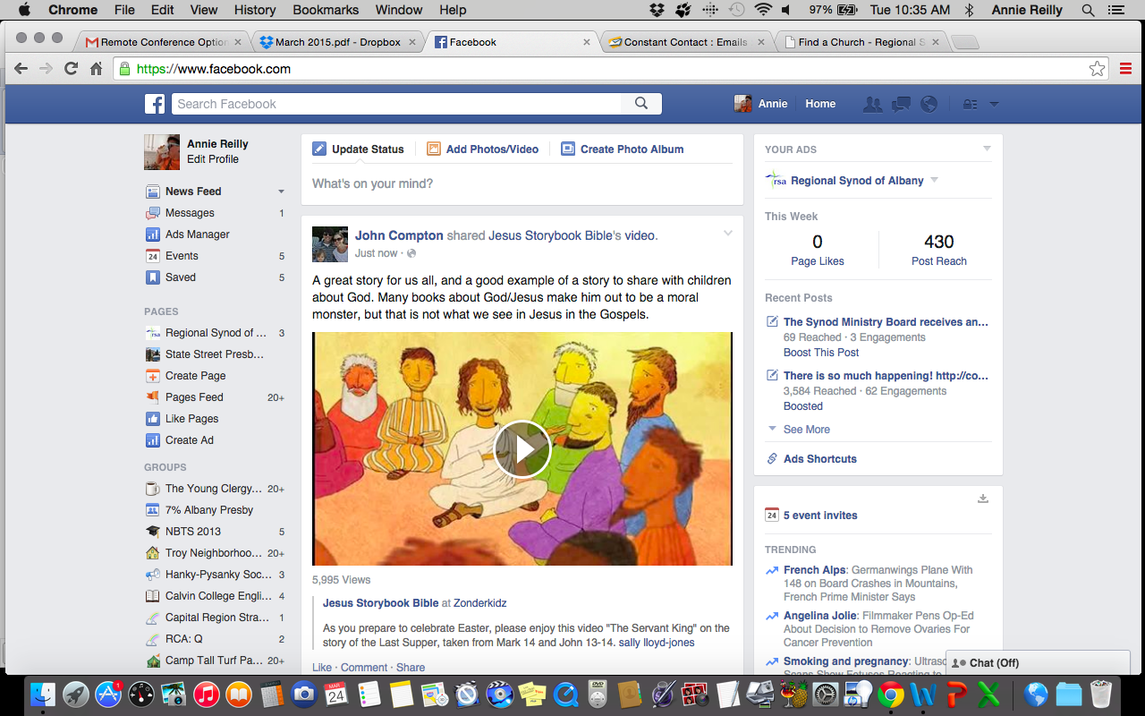
Looking at your newsfeed, on the left-hand
side, under the heading “Pages” there will be
an option to “Create Page”. This is where
you will start.

Step 2:

Next, you will be taken through a series of options on how to begin your Church Facebook Page. These are important in how Facebook categorizes your page and how others will find it.

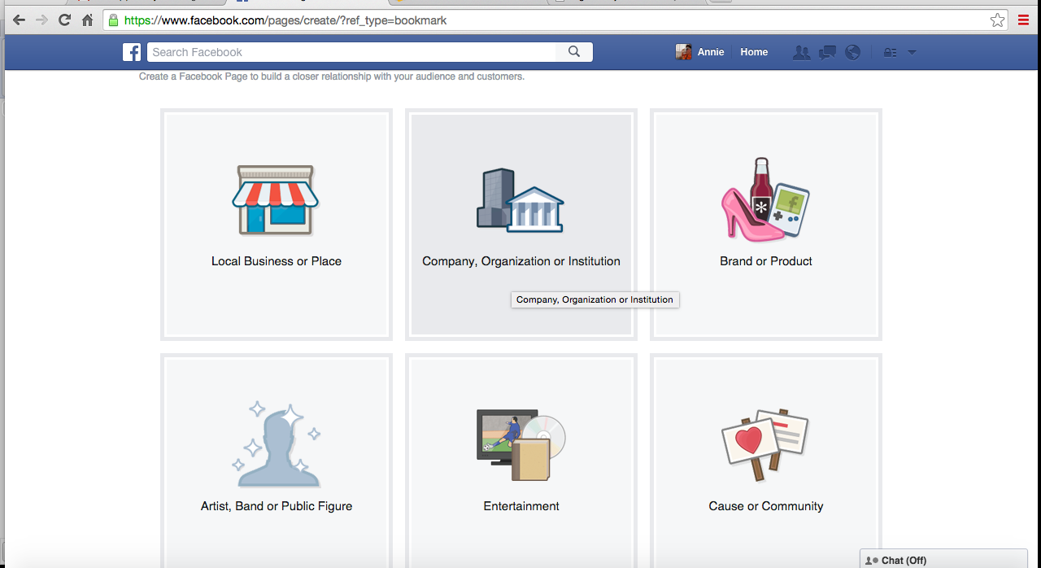
Your church falls under
“Company, Organization,
or Institution”

Step 2a:
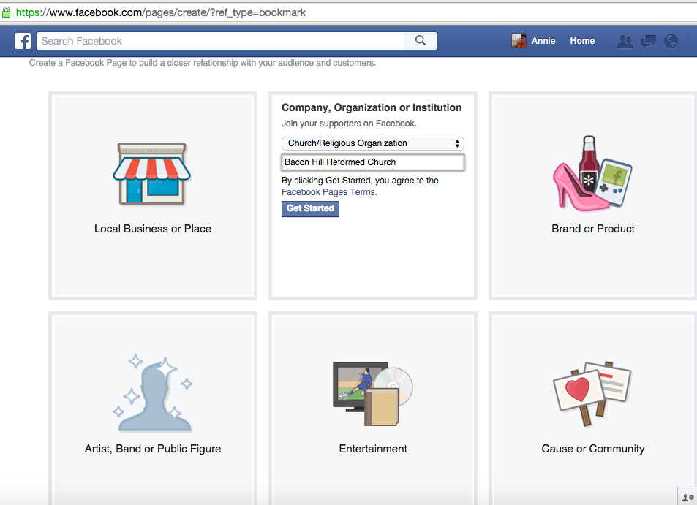
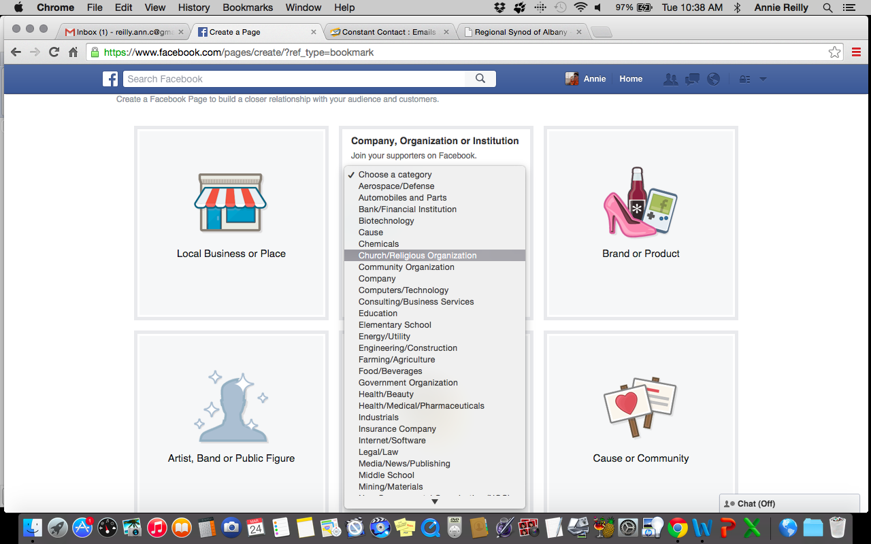

Step 3:
Enter your basic information to get you started. You will add more later.
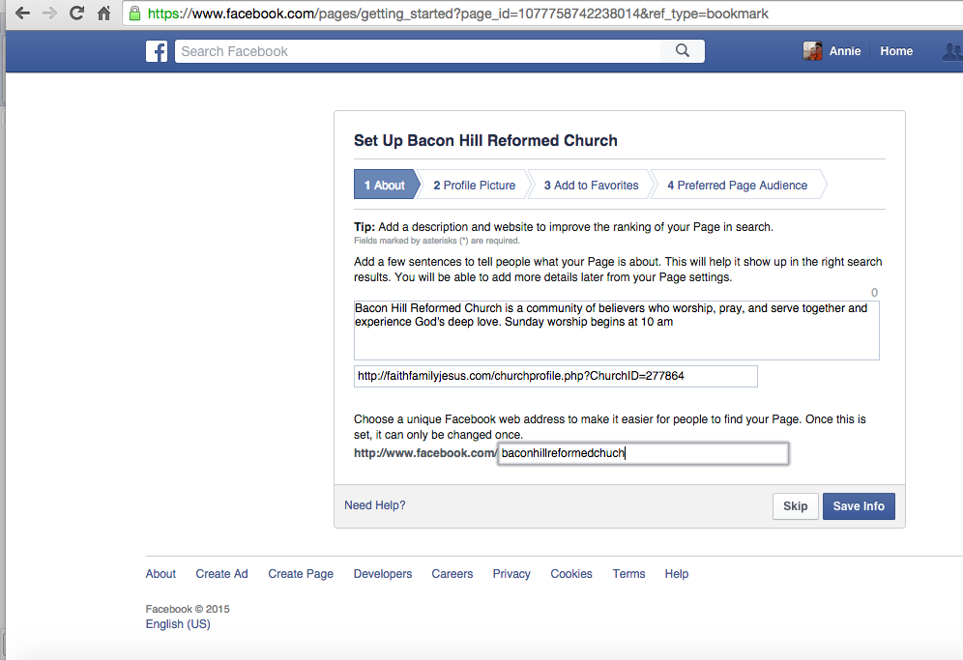

Give a brief description of your church.

You can add your church web
address if you have one.

Pick an obvious name for your
Facebook specific location

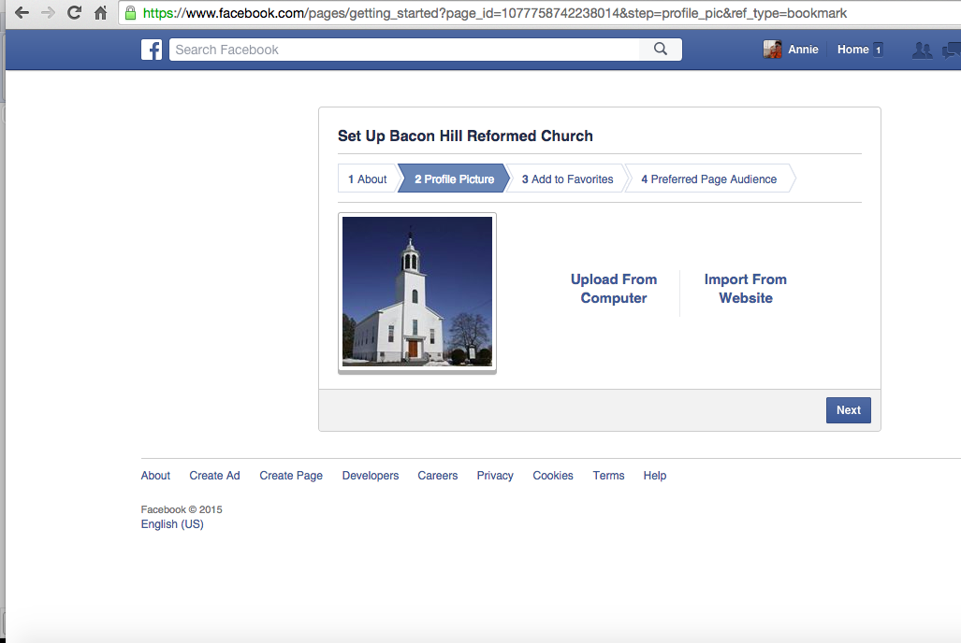
Upload a photo to serve as the profile picture.
This should be an image of your building or
church sign; something that does not change and
can be easily identified as signifying your church.
The image of a person is not a good choice here.

Use this option if the picture of your church
is on your computer.

Use this option if the picture of your church is on
your church website.

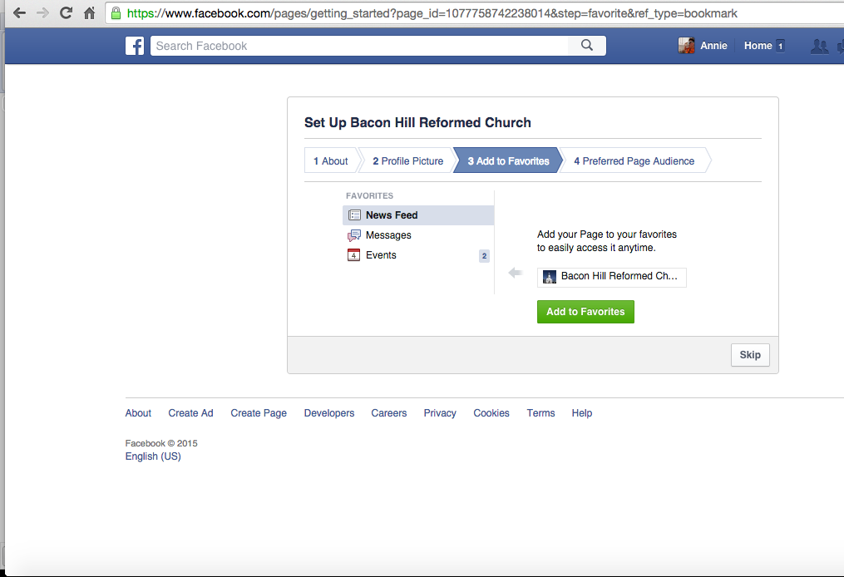
This setting gives you the option of listing
your Church Facebook Page in the left
sidebar of your personal Facebook page, in
order for you to be able to access it easily.
This step can be skipped if you chose.

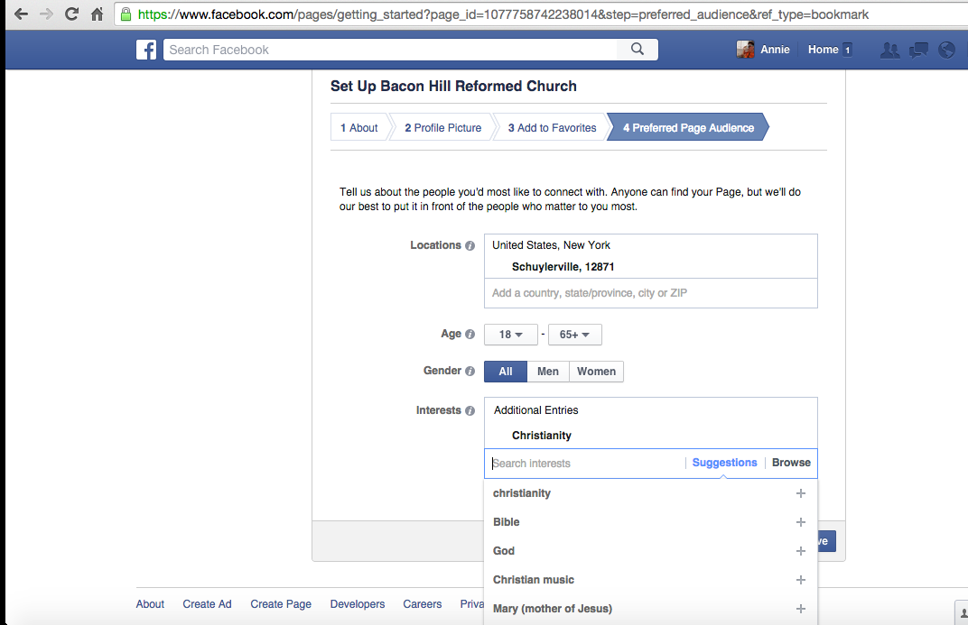
Finally, this screen will let you set up
the preferred audience of your Facebook
page. The information you provide here will
help Facebook suggest your page to people
who might be interested in checking out
your church. You can also indicate a set of
“Interests” that Facebook should look for
when choosing who to suggest your page to.
“Christianity”, “Bible”, “Church” are all
good ideas here. You can also indicate
“wedding”, “funeral”, or even “preschool”.

Step 4:
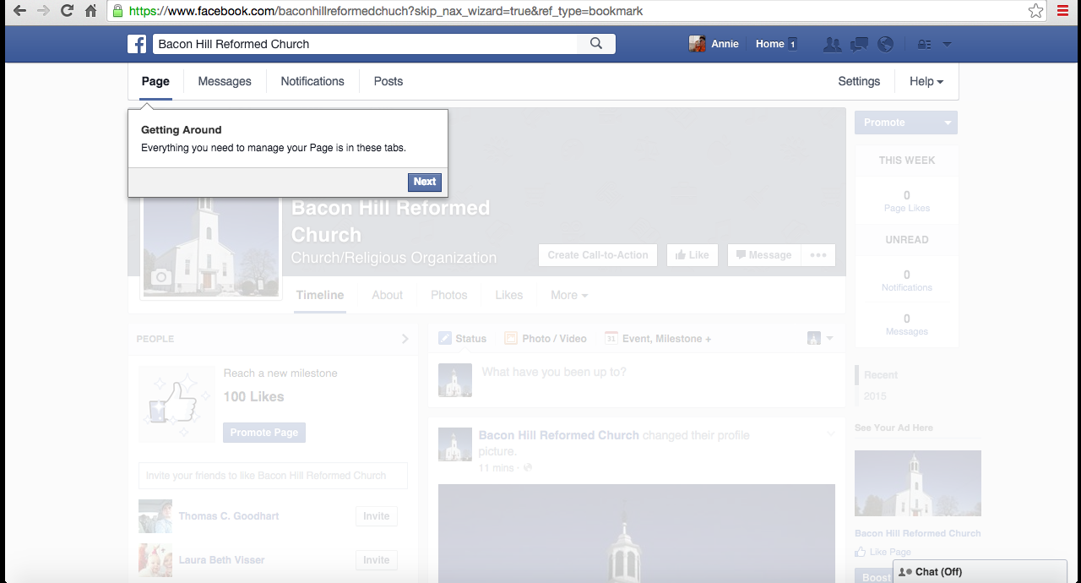
After completing the previous steps, your page will be created. Facebook will take you through a mini-tutorial, showing you where things are and how to use certain features of the page. Click “next” through this tutorial at your own pace. It’s very quick and highlights four features.

Step 5:
Customize your page and make sure your church information is on there. This is the directory part of your Facebook presence.

Add a cover photo (optional)
Click over to the “About” section and
scroll down the page. Anywhere the text
is blue, you can add that information about
your church. All of it is optional, but the more, the better.
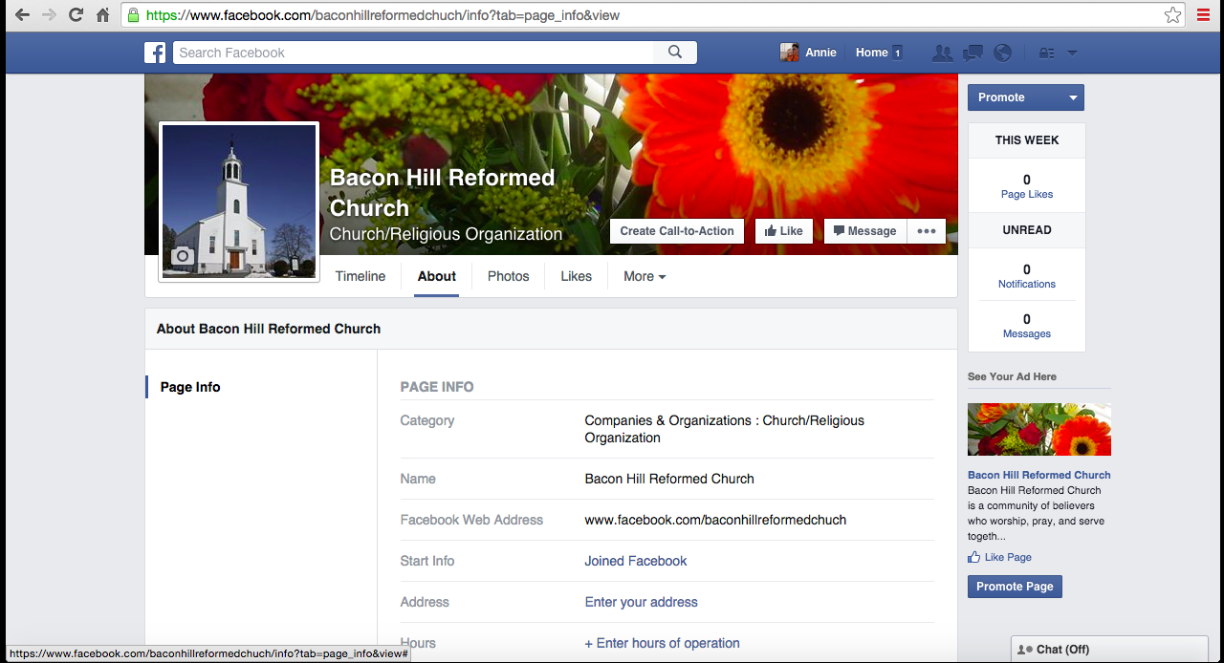
This is your weekly data report. Only you, as the page administrator, see this report.

Should you choose, you can “promote” your page. This will create a sidebar advertisement for your church that will show up on the newsfeed of those who are in the same geographic area as you and share the interests you previously indicated. There is a cost to “promote” your page.

At this point, you’ve done the minimum amount of work to make a Church Facebook Page. You have a place that is visibly associated with your building and has all the information about location, contact info, and service times. There is more you can do to customize your page and create a vibrant online hub for your congregation.

Upload photos from worship and events. Make sure Go to your “Timeline” and write
to get parental permission if there are photos of a status update that invites,
children. promotes, or celebrates an event.
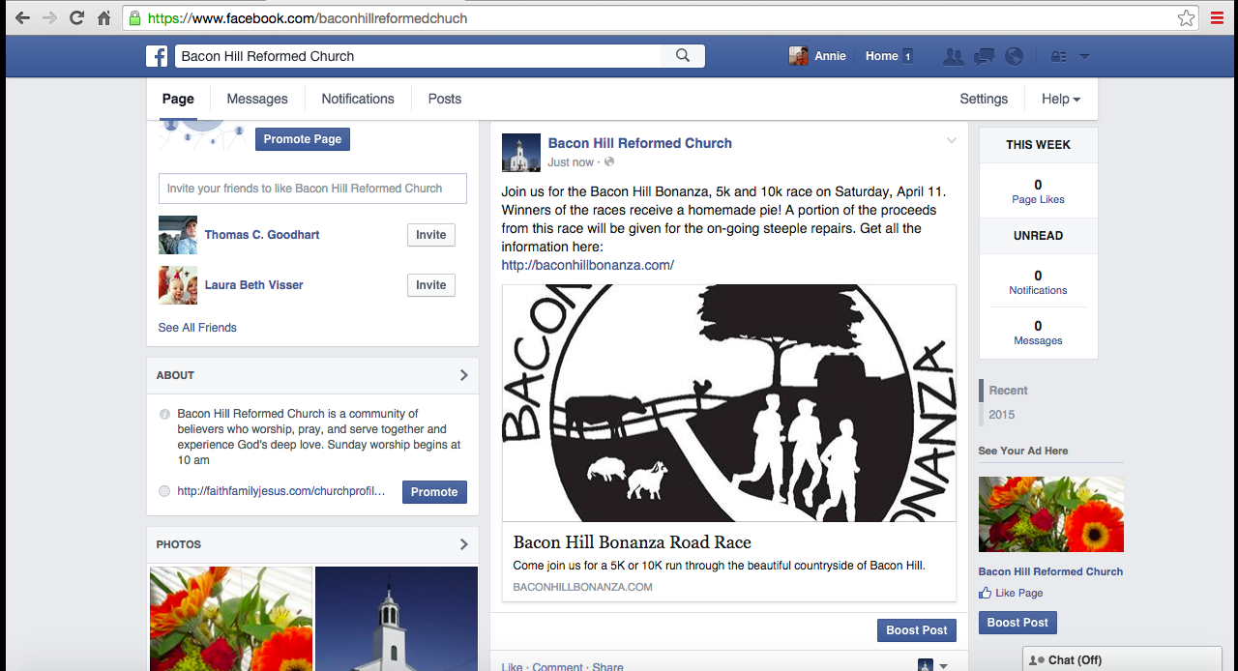
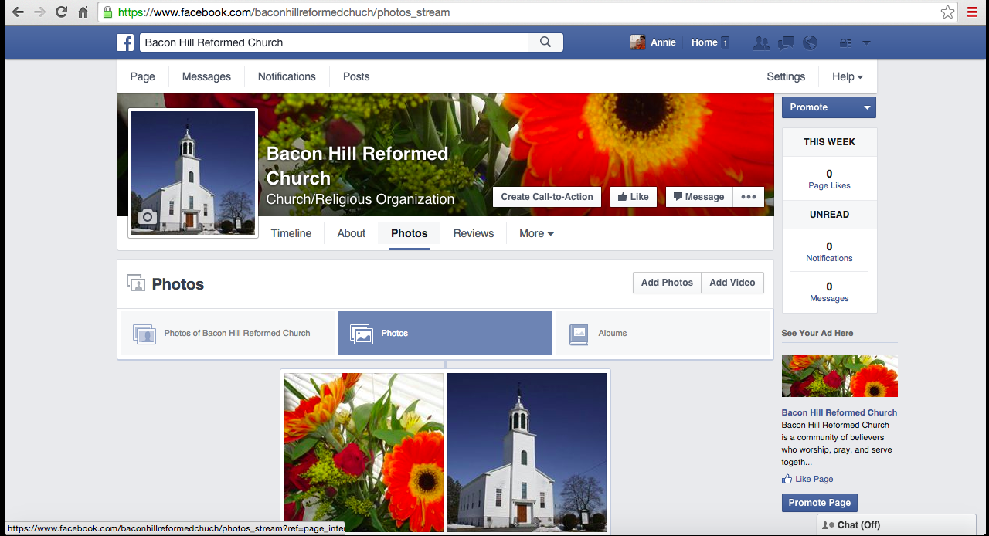
How to Use Your Church Facebook Page:

Status:
Every time that you post a Status Update on your Timeline, members of Facebook who “like” your page will receive those updates in their newsfeed. Status are a great way to promote events like fundraisers, mission projects, special worship services (Holy Week, baptism, All Saints). They are also a great way to reach out to the boarder community. Some churches choose to share book recommendations, news articles, videos, or scripture verses. Statuses can also gather community information e.g. “Seeking pianist for Sunday mornings” or “Anyone interested in starting a running group?”

Photos:
You can create separate photo albums to hold photos from different events. You could have one for “Members” or “Mission Projects” or “Dinner” or “Youth Group”. With the ease of taking pictures, you can encourage members to take pictures at events and then send you (or whoever is in charge of your Facebook Page) the pictures for posting. This will give you more Facebook content and promote all the facets of your community.

Likes:
In order to get your Facebook page viewed, individuals either will use the search function on Facebook to find your page, or they will be invited to “like” it. These invitations for “liking” come directly from your Facebook page. During the page set up process, you will be prompted to invite your friends (on Facebook) to “like” your page. They in turn will invite others and so on and so forth. You can put “Like Us on Facebook” in your church bulletin to encourage members to like the page and thus receive updates. You can also put “Like Us on Facebook” on a church sign or marquee to let the community know that more information about your church can be found online. “Liking” is akin to subscribing to receive updates and access to information.

We at the Regional Synod of Albany hope that this has been a helpful tutorial. If you have any futher questions about Facebook or encounter any difficulties, ask the youngest person in your youth group/confirmation class/congregation to help you. Or get that person to recruite their grandchild to assist, whatever situation is right for you.

