2021 MINUTES

The Regional Synod of Albany

Reformed Church in America

Annual Assembly
Fowler Camp and Retreat Center
Speculator, New York

June 5, 2021

Directory

1790 Grand Blvd, Schenectady, NY 12309
(518) 374-4573
E-mail: synodalbany@gmail.com
Website: www.albanysynod.org

BOARD OF TRUSTEES AND EXECUTIVE COMMITTEE

Rev. Steve Norden President
Rev. Matthew van Maastricht Vice President
Rev. Paige Convis Past President
Rev. Robert Hoffman Stated Clerk
Ms. Lynn Barnes Personnel Committee
Mr. Mark Watson Finance Committee
Rev. Nancy Ryan Overtures and Judicial Business Committee
Rev. Marcy Rudins Synod Ministries Board
Mr. Justan Foster Fowler Board of Trustees
Mr. Steve Mattice Schoharie Classis
Rev. Rich Scheenstra Schenectady Classis
Ms. Noreen Fargione Albany Classis
Rev. Derek DeJager Columbia Greene Classis
Ms. Diane Reynolds Montgomery Classis
Rev. Sarah Palsma Rochester Classis
Rev. Abby Norton Levering Synod Ministries Coordinator
Rev. Kent Busman Fowler Executive Director
Ms. Allison Stone Synod Finance Manager

Albany Synod Staff

Rev. Abby Norton Levering Ministries Coordinator
Rev. Robert Hoffman Administrator/Stated Clerk
Ms. Allison Stone Finance Manager
Rev. Dr. Sherri Meyer Veen Faithwalking/Churches Learning Change
Ms. Sandy Cornwell School of Ministry Administrator
Rev. Lindsey DeKruif Fellowship Program/First Call Administrator
Rev. Alisha Riepma Communications Coordinator

Fowler Camp and Retreat Center Staff

Rev. Kent Busman Executive Director
Ms. Josey Bierd Assistant Director
Ms. Lauren Cleworth Administrator
Mr. Harv Zegstroo Operations Manager
BOARDS

Fowler Board of Trustees

Pete Faas Rochester Classis 2022
Dawn Olsen Columbia Greene Classis 2022
Pat Kinne Program Committee 2022
Emmy Katz At Large 2022
Tim Combs Partner 2022
Laura O’Brien Schoharie Classis 2023+
Justan Foster Albany Classis 2023
Nicole Gentile Development Committee 2023
Jenna White At Large 2023
Aaron Ray Partner 2023
Jamie Elwood Schenectady Classis 2024
Jim Gunty Property Committee 2024
Beth Luck Montgomery Classis 2024
Heather Kramer At Large 2024
Janelle Richardson Partner 2024
Kent Busman Executive Director
Lauren Cleworth Administrator/Clerk
Harv Zegstroo Operations Manager
Robert Hoffman Synod Administrator

Albany Synod Ministries Board

Lou Hannett Columbia Greene Classis 2022
Sharon Johnson Albany Classis 2022
Jason White Schenectady Classis 2022
Nominee Rochester Classis 2022
Ed VanKempen Columbia Greene Classis 2023+
Jeff Mc Ilrath Montgomery Classis 2023
Jim Pettis Jr. Schenectady Classis 2023
Rich Dykstra Schoharie Classis 2023+
Marcy Rudins Albany Classis 2024+
Deb Sanburn Montgomery Classis 2024
Jerri Mattice Schoharie Classis 2024+
Nominee Rochester Classis 2024
Abby Norton Levering Ministries Coordinator
Steve Norden Synod President
Matthew van Maastricht Synod Vice President
Paige Convis Synod Past President
Kent Busman Fowler Executive Director

PERMANENT COMMITTEES

Finance Committee

Jay Hine Schoharie Classis 2022
Scott Bensink Rochester Classis 2022
Andrea DiPace Columbia Greene Classis 2023
Mark Watson Schenectady Classis 2024+
Betsy Darrow Albany Classis 2024
Robert Hoffman Synod Administrator
Allison Stone Finance Manager
Abby Norton Levering Ministries Coordinator

Personnel Committee

Roger Krutz Albany Classis 2022
Will Ryan Montgomery Classis 2022
Charles Weissner Columbia Greene Classis 2023
Lynn Barnes Schenectady Classis 2024+
Nancy Rasweiler Columbia Greene Classis 2024+
Robert Hoffman Synod Administrator
Abby Norton Levering Ministries Coordinator

Overtures and Judicial Business Committee

Mike Horan Schenectady Classis 2022
Richard Schuster Rochester Classis 2023
Matthew van Maastricht Schenectady Classis 2024
Jeffrey Kelley Schoharie Classis 2025
Nancy Ryan Montgomery Classis 2026
Robert Hoffman Synod Administrator

Nominations Committee (stated clerks)

Nancy Landrigan Albany Classis
Patti Varga Columbia Greene Classis
Randy Karcher Montgomery Classis
Anita Manuele Rochester Classis
Lindsey DeKruif Schenectady Classis
Richard Dykstra Schoharie Classis
Robert Hoffman Albany Synod
- Denotes Second Term

2021 Minutes
REGIONAL SYNOD OF ALBANY

The annual assembly of the Regional Synod of Albany was held on June 5, 2021 at the Fowler Camp and Retreat Center in Speculator, New York. Rev. Paige Convis, president, presided.

- GATHERING

President Convis called the meeting to order at 12:00pm, following the lunch provided by the Fowler Staff. The gathering worship service was led by Rev. Mashona Walston and Justan Foster.

- FORMATION

Nineteen (19) ministers and Twenty (20) elders, including the President, signed in as delegates making a total of Thirty Nine (39) voting delegates and officers in attendance.

Delegate Roster
MINISTERS ELDERS
Albany Classis
Bruce Cornwell Ginny Fissette
Mashona Walston Richard Vanderbilt
Matthew Rogalski Sandra Quay
Chris Vande Bunte Mary Jane Brown
Columbia Greene Classis
Chuck Weissner Gary Smith
Lou Hannett
Bret Smith
Jim Andrews
Montgomery Classis
Ryan Cogswell Deb Sanburn
Brian Engel Lynne Stenberg
Susan Huizenga Judy Keeler
Betsy Westman Vivian Cantello (absent)
Rochester Classis
Brian Maag John Stratton
Terry Geist
Schenectady Classis
Lisa VanderWal Lou Smith
Kent Mc Heard Beverly Harrington
Jenn Legg Kelly Clement
Jonathan Vanderbeck Brad Lewis
Schoharie Classis
Chuck Hesselink Steve Mattice
Alisha Riepma Lauri Schumacker
Heather Kramer Roger Wright
Rett Zabriskie Susan Pendergast (excused)
Officers
Paige Convis Patti Varga (excused)

The following staff, board or committee members, and guests were welcomed and granted privilege of the floor:
Synod Staff: Abby Norton Levering, Allison Stone and Robert Hoffman.
Fowler Staff: Kent Busman.
Fowler Board of Trustees: Justan Foster.
Overtures and Judicial Business Committee: Nancy Ryan.
Guest: Matthew van Maastricht
(Robert Hoffman, Stated Clerk, noted that additional guests may be present for the Judicial session of the agenda).

MOTION: To welcome the guests and grant them privilege of the floor. (CARRIED)
- AGENDA

Arrival and Delegate Sign In
Call to Order
Opening worship
Delegate and Guest Introductions and Setting the bounds of synod
Consent agenda
Committee Appointments
Summary of Major Actions (SBOT, ASEC, FBOT)
Administrator’s Report
School of Ministry Report
Churches Learning Change/ Faithwalking Report
Albany Synod Fellowship Program Report
Report from Camp Fowler
General Synod Council Report
New York State Council of Churches Report
President’s Report
Ministries Coordinator’s Report
Ministries Board Report
Finance Report
2020 Audit Review
2022 Proposed Budget
2022 Proposed Assessments
OJB Report-
By Laws Recommendations
Judicial Business
Election of Officers
Commissioning and closing worship
Adjournment

MOTION: To approve the agenda with flexibility allowed. (CARRIED)

CONSENT AGENDA

President Convis introduced the part of the agenda called the Consent Agenda. This part consists of the following reports:
Standing and Review Committee Appointments
Summary of Major Actions of the Albany Synod Board of Trustees, Albany Synod Executive Committee and the Fowler Board of Trustees
Synod Administrator’s Report
Albany Synod School of Ministry Report
Faithwalking and Churches Learning Change Reports
Albany Synod Fellowship Program Report
Albany Synod Mediation Team Report
Report from Camp Fowler
Report from the General Synod Council
Report from the New York State Council of Churches

President Convis noted that including these reports in the Consent Agenda, the synod assembly will be receiving them all in one action. If, however, any delegate would like to engage in discussion about a specific report, that report could be removed from the Consent Agenda and considered individually. Hearing no requests to remove any reports from the Consent Agenda,

MOTION: To approve the Consent Agenda. (CARRIED)

Standing and Review Committee appointments
Committee on Accounts (two minister and three elder delegates) will review the 2022 proposed assessments and the proposed 2022 budget.
Revs. Kent Mc Heard and Bruce Cornwell; elders Susan Pendergast, Gary Smith and Judy Keeler

General Review Committee (four minister and four elder delegates) will review the President’s Report, the Mission Council and Ministries Coordinator’s Reports.
Revs. Lisa Vanderwal, Chuck Wiessner, Mashona Walston and Rett Zabriskie; elders Steve Mattice, Deb Sanborn, Mary Jane Brown and John Stratton

Resolutions Committee (one minister and one elder delegate) will prepare appropriate resolutions for the synod.
Rev. Jenn Legg and elder Terry Geist

Tellers (two ministers and two elder delegates) will oversee the tabulation of votes and assist in distribution of materials at the synod meeting.
Revs. Brian Maag and Ryan Cogswell; elders Richard Vander Bilt and Lynne Stenberg
Albany Synod Board of Trustees
The Albany Synod Board of Trustees met six (6) times since the May 5, 2019 assembly. Those meetings were held on May 30, 2019, November 14, 2019, March 12, 2020, May 28, 2020, November 12, 2020 and March 11, 2021. The summary of the major actions accomplished by the board includes:
- Approval of a $10,000 grant extension to the Lynnwood Reformed Church.
- Acceptance of board member resignations and the appointment of board members by classes, Synod Ministries Board and the Fowler Board of Trustees.
- Approved contracting with Pinnacle Roofing to replace the roof on the Albany Synod office building.
- Undertaking a thorough review of the grant ministries of Albany Synod.
- Overseeing the Finance Committee’s review of the investment policies and use of the funds.
- Appointment of authorized signatories for the investment funds.
Albany Synod Executive Committee
The Albany Synod Executive Committee met fourteen (14) times since the May 5, 2019 assembly. Those meetings were held on May 30, 2019, September 5, 2019, September 19, 2019, November 14, 2019, March 12, 2020, April 1, 2020, April 23, 2020, May 28, 2020, July 17, 2020, September 10, 2020, October 7, 2020, November 12, 2020, February 18, 2021 and March 11, 2021. The summary of the major actions accomplished by the board includes:
- Approved holding a classis executive committee summit to help process the 2020 Vision Task Force Report.
- Appointed Anita Manuele as temporary clerk to work with the Overtures and Judicial Business Committee in reviewing an appeal.
- Approved funding for the Churches Learning Change/ Faithwalking ministry for 2019-2020 and for 2021-2022.
- Approved funding for the Albany Synod School of Ministry staff and instructor support.
- Endorsed support of H.R. 2407 and the “No Way To Treat A Child” campaign.
- Appointed authorized signatories for Albany Synod bank accounts.
- Appointed chairpersons for Albany Synod’s Personnel, Finance and Overtures and Judicial Business Committees.
- Approved the Personnel Committee’s salary recommendations for 2020 and 2021.
- Appointed delegate and corresponding delegates to General Synod.
- Approved the Finance Committee’s Authorization Schedule recommendation for 2020 and 2021.
- Accepted resignations and made appointments to Albany Synod committees and Ministries Board and the Fowler Board of Trustees.
- Approved the Standing Committee appointments for the annual assembly.
- Approved a 20% assessment relief for the 2020 second quarter amounts.
- Approved the Finance Committee’s PPP Loan application requests for 2020 and 2021.
- Approved postponing the 2020 assembly and holding a “Still Together” event on the scheduled date.
- Approved sending an overture to General Synod requesting more socially screened investment options for the minister’s pension plan.
- Approved the Nominations Committee’s recommendations for committee vacancies, the SMB and the Fowler Board of Trustees.
- Approved the proposed 2021 budget.
- Approved the 2021 assessment to be $39.00 per confessing member.
- Approved the 2019 Financial Review reports as presented by Wojeski and Company.
- Approved the Personnel Committee’s recommended changes to the Albany Synod Employment Handbook for 2020 (Sexual Harassment Policy) and updates for 2021.
- Affirmed work done to create the Albany Synod Church Supervision Handbook and endorsed it as a resource for congregations and classes.
- Approved the Personnel Committee’s recommended housing allowance for the Ministries Coordinator.
- Approved appointment of a task force to explore and recommend avenues of engaging members of local congregations in adaptive change.
- Approved funding for another round of the Albany Synod Fellowship Program for 2021-2023.
- Instructed the OJB Committee to work on forming a more proper procedure to help a church transfer to a new classis; and to present amendments to the By Laws allowing for electronic meetings.
- Voted to reschedule the May 1, 2021 assembly to June 5, 2021 to be held at Camp Fowler.

Fowler Board of Trustees
May 2020 – April 2021
Financial

· To approve Kent Busman as the authority to sign off on the PPP Loan and complete the process. – action 20-34, 5/1/20

· To withdraw from Family Funds the amount of $300,000 for the cost of building 2 new shower houses and support the camp for the remainder of 2020. – action 20-35, 8/10/20

· To remove Tom McIlroy and Jenni Yeski and add Pat Kinne and Bill Ports as signatories to the Schwab and Fenimore accounts. – action 20-25, 8/10/20

· The Fowler Executive Director will receive a 2% raise in 2021. – action 20-28, 11/18/20

· The amended budget for 2021 is approved. – action 20-29, 11/18/20

· The minister’s housing allowance for 2021 is approved. –action 20-30, 11/18/20

· Maintain a balance in the Schwab account so that the account stays open. –action 20-31, 11/18/20

· To keep a balance of $200.00 in the Schwab account to keep an open account. – action 21-2, 1/27/21

· To permit the Human Resource Team to move forward preparing a compliant employee handbook at a cost of no more than $3000.

Personnel

· Add Josey Beird to Fowler’s health insurance and also add Connor Brady as domestic partner. – action 20-33, 11/19/20

Governance

· To accept the Governance Team’s recommendation of the slate of Nicole Gentile, Jenna White, Emmy Katz and Aaron Ray to serve as Fowler Board members. – action 20-24, 8/26/20

· Recommend amending by-laws section 1 and 2 to read that the 3 at large members do not need to be RCA church members. – action 21-5, 1/27/21

SYNOD ADMINISTRATOR’S REPORT

The position of Synod Administrator grew out of the restructuring of Albany Synod in 2012 when the old Synod Executive position was divided into administrative responsibilities and program oversight. I was hired as Synod Administrator in July of 2013 working two days a week. Abby was hired shortly thereafter to be the Synod Ministries Coordinator. The work of the Synod Administrator is separate from that of the Stated Clerk even though there is some overlap.

My work as Synod Administrator is broken down into several areas of oversight. They include:

Support the synod officers in leadership of the RSA Executive Committee, Synod Board of​ Trustees, and the annual assembly of the RSA.

Supervise all synod support staff on behalf of the Synod Executive Committee.​

Participate in co-operative endeavors with the Synod Ministries Coordinator.​

Serve as liaison to the Fowler Board of Trustees.​

Work with the ASEC, SBOT, Finance Committee and the Ministries Coordinator to develop​ strategies that ensure sufficient funding for the RSA to develop and promote the continuing RSA ministries.

Provide for the maintenance and care of the RSA offices and building.​
Other duties as may be assigned​

While it is true that the work I do with the respective committees of my oversight does follow a cyclical pattern, COVID limited the amount of time I spent in the office fulfilling those responsibilities. I maintained that limited presence to one day a week but then kept in contact with the other staff by email, phone or zoom meetings. Abby and I found it necessary to have a weekly check in time just to keep informed of what we were working on that week and to look into the next week(s) for other important items.
All of our committee meetings have been held by zoom which has its good and less than good aspects. While it is more convenient for everyone to join the meeting from home, the exchange of ideas and conversations is a bit more limited and is affected by unstable internet connections. Each of the committees have done good work throughout this past year and have accomplished much in keeping our synod moving forward.
The monthly meeting with the Christian Educators on the second Tuesday of every month was discontinued at first and then re-started using zoom. It was also scheduled at a time when more could participate and is still happening. I do miss the in person gatherings and hands on learning shared together.
Participation at classis meetings also changed as some of them did not meet and others met by zoom. I was able to attend and listen at a few meetings but missed out on the casual conversations held around the meal or fellowship time where delegates might ask about the regional synod. I believe it is important for me to attend these meetings even though it isn’t part of the responsibility of the position.
The office staff have shifted to monthly zoom meetings where we share our work schedules and plans for future events and activities. Our check in times have also helped us to stay connected with our involvements outside the office.
My area of responsibility in the care and oversight of the 1790 facility is the unknown factor among all the responsibilities of the synod administrator position. Last year we contracted to have a complete overhaul of the roof on the 1790 building. This seems to have solved the leaks we have struggled with over the past decade. All in all, things at 1790 are going well. The flower garden is blooming and we hope to have another vegetable garden this coming summer.
My future plans are to continue working in this capacity for as long as needed and able. I look forward to new challenges and additional ministry opportunities which God may place before us.

Respectfully Submitted,
Robert Hoffman, Synod Administrator

Albany Synod School of Ministry
The School of Ministry (SoM) offers six courses over the span of two years as basic education for those seeking the role of commissioned preaching elder. It is also open to all who wish to deepen their own personal theological experience or those in the discernment process. To date, twenty-one students have participated in the various classes and eleven will have completed all 6 required courses in May. These classes may serve as a pathway for those interested in becoming a commissioned pastor.
The 2020-2021 courses:

· Biblical Exegesis with Rev. Steven Rodriquez, instructor

· Systematic Theology with Dr. Matthew van Maastricht, instructor

· Preaching and Sermon Preparation with Dr. Bill Levering, instructor

In September 2021, Old Testament Introduction and History will be offered with Dr. Johan Bosman. Students are needed with a minimum of 6-8 participants to maintain the Schools viability. I encourage you to look within your church membership and identify persons who may show interest in deepening their church role or their personal enrichment.
All SoM classes are currently being taught by videoconferencing, making it possible for students from the farthest corners of Albany Synod to participate. There are eight 3-hour sessions per course but courses such as preaching will have in-person requirements.
The School of Ministry classes will cost $300 due at the time of registration. Students are encouraged to seek scholarship assistance from their local church and classis.

Albany Synod School of Ministry Board
The School of Ministry is overseen by the Albany Synod Ministries Board. The School of Ministry Board includes Rev. Matthew J. van Maastricht, Rev. Steven Rodriguez, Rev. Abby Norton-Levering, Rev. Robert Hoffman, and Sandy Cornwell, Administrator.

Who should sign up for SoM classes?

● those in training to be preaching elders (PE)
● those in training to become Commissioned Pastors (CP)
● Anybody else who is interested in the subjects offered! Church leaders, elders, deacons, Christian educators, pastors etc.

Potential PEs and CPs should be aware that their classes may require additional work in these subject areas beyond completing the SoM class. Classes also will conduct their own examinations of PE and CP candidates to explore their mastery of the subject matter. PE and CP candidates who are under care of their classes must submit a written classis endorsement as they register for SoM classes. Classes will be updated by the School of Ministry administrator of the student’s performance and course completion. It is also encouraged that classis examinations be given throughout the study process.

Interested in more information?
Contact: Sandy Cornwell, School of Ministry Administrator, crccsandy@gmail.com

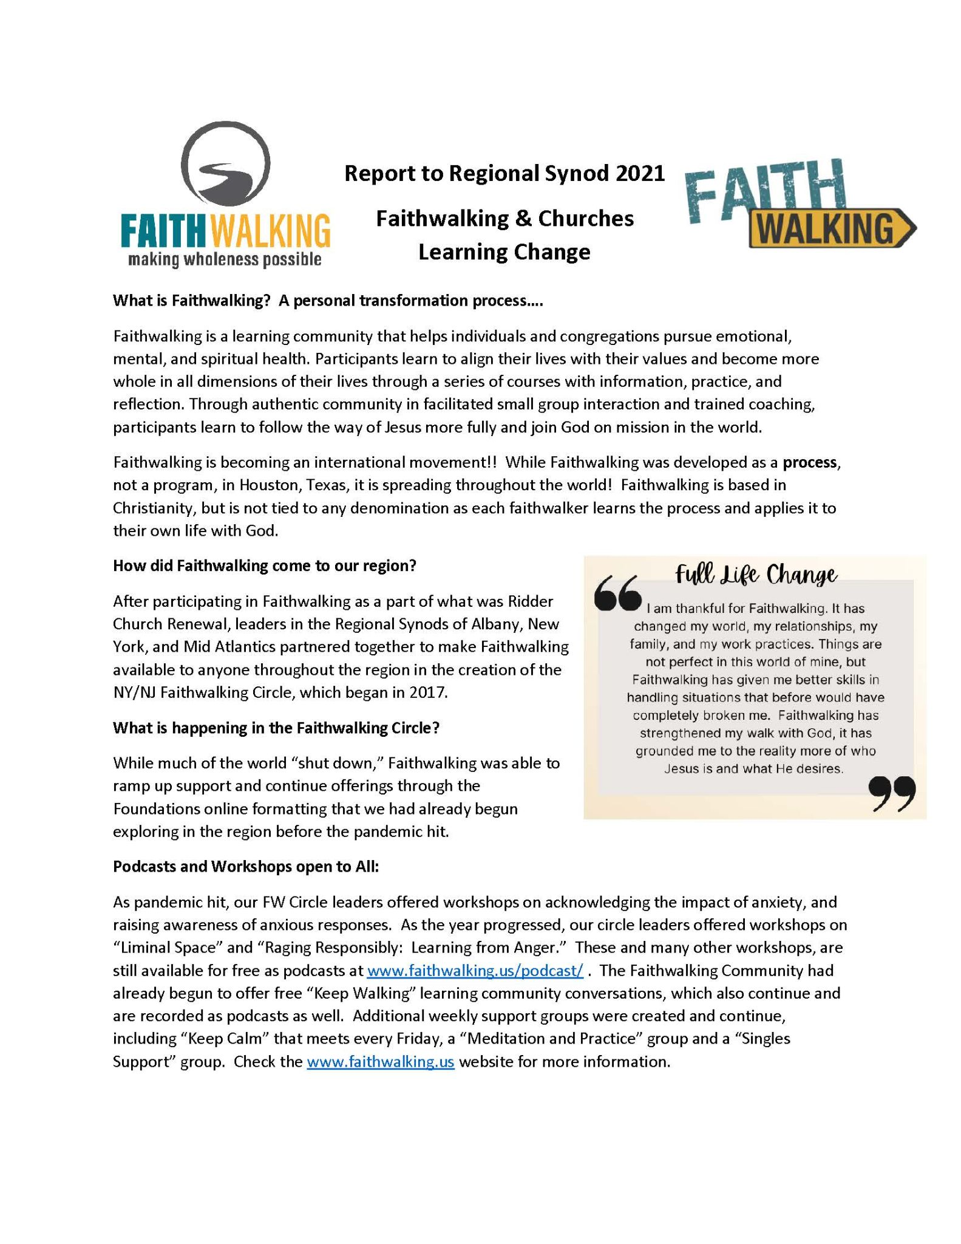
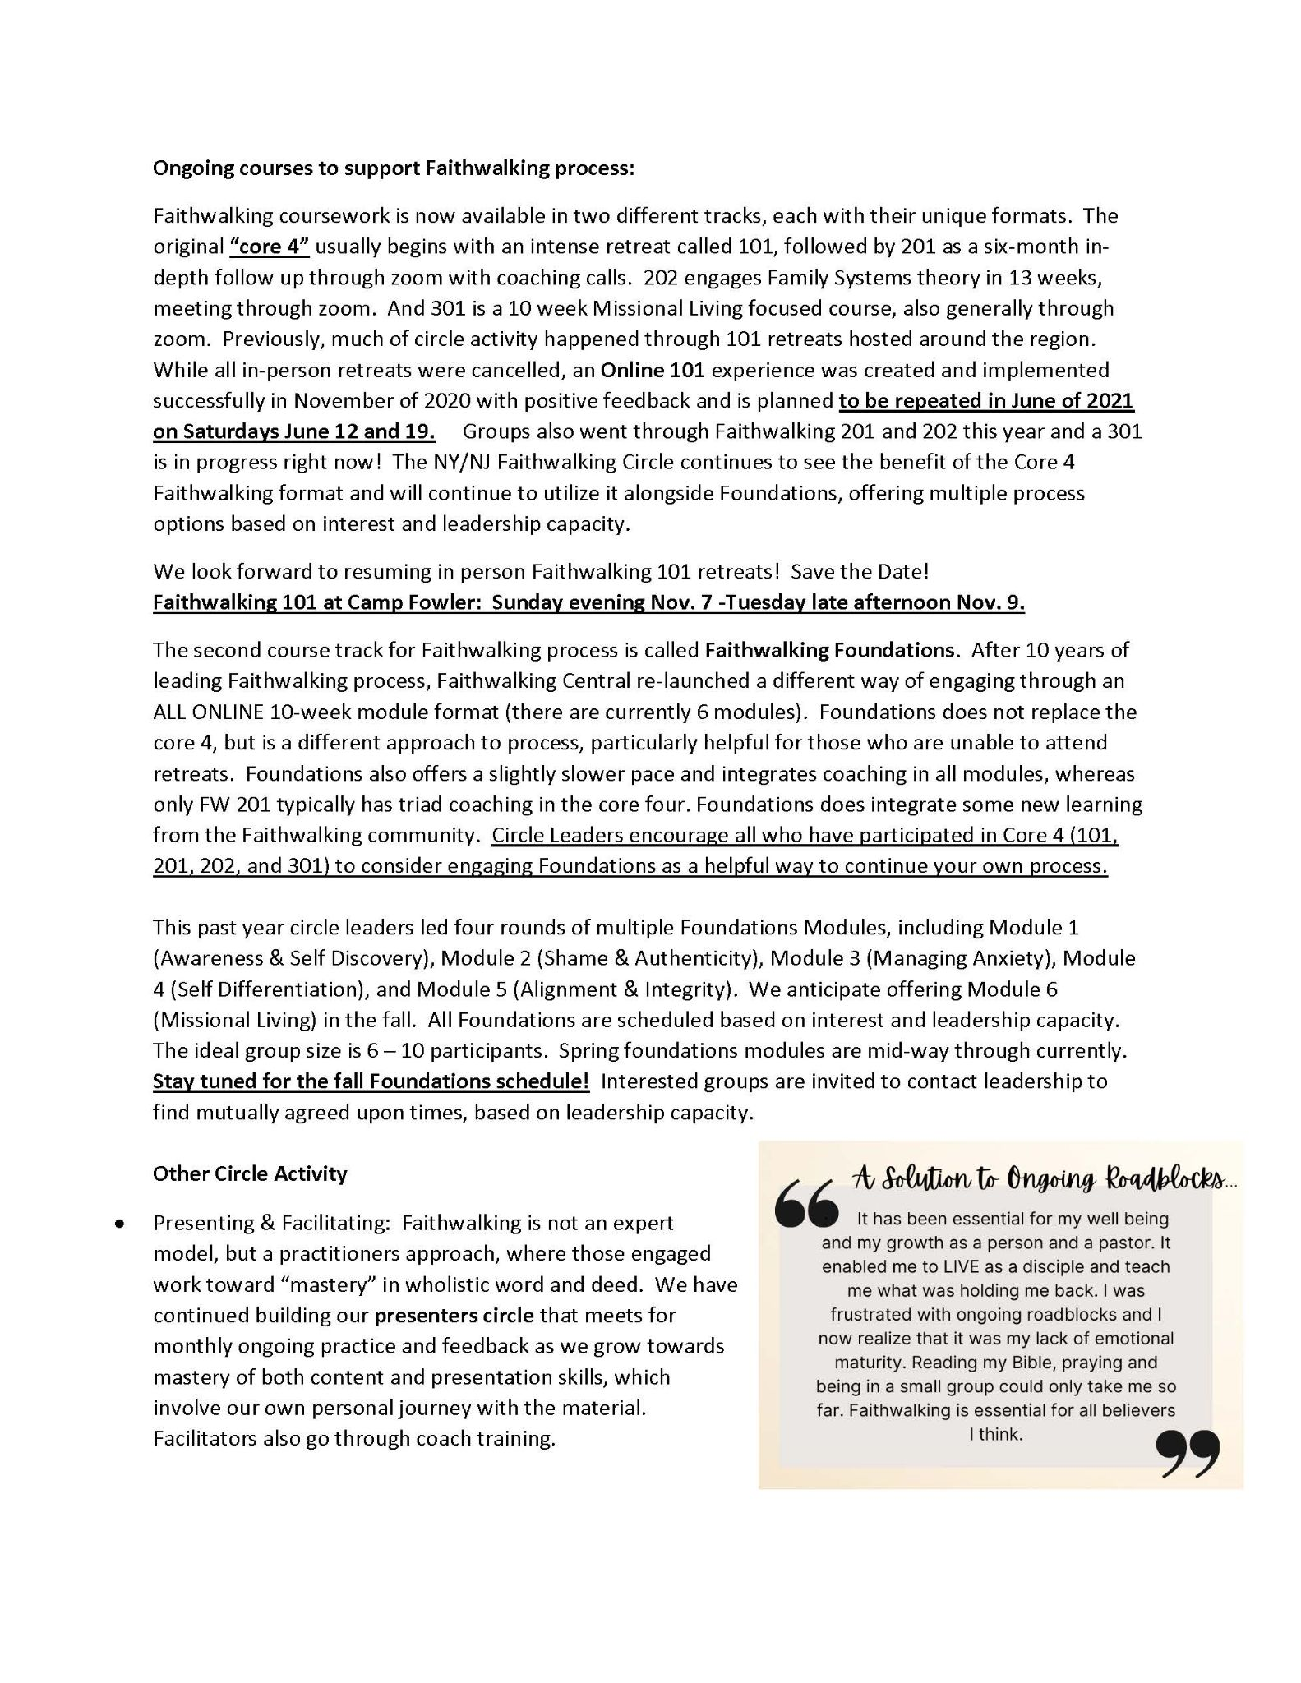
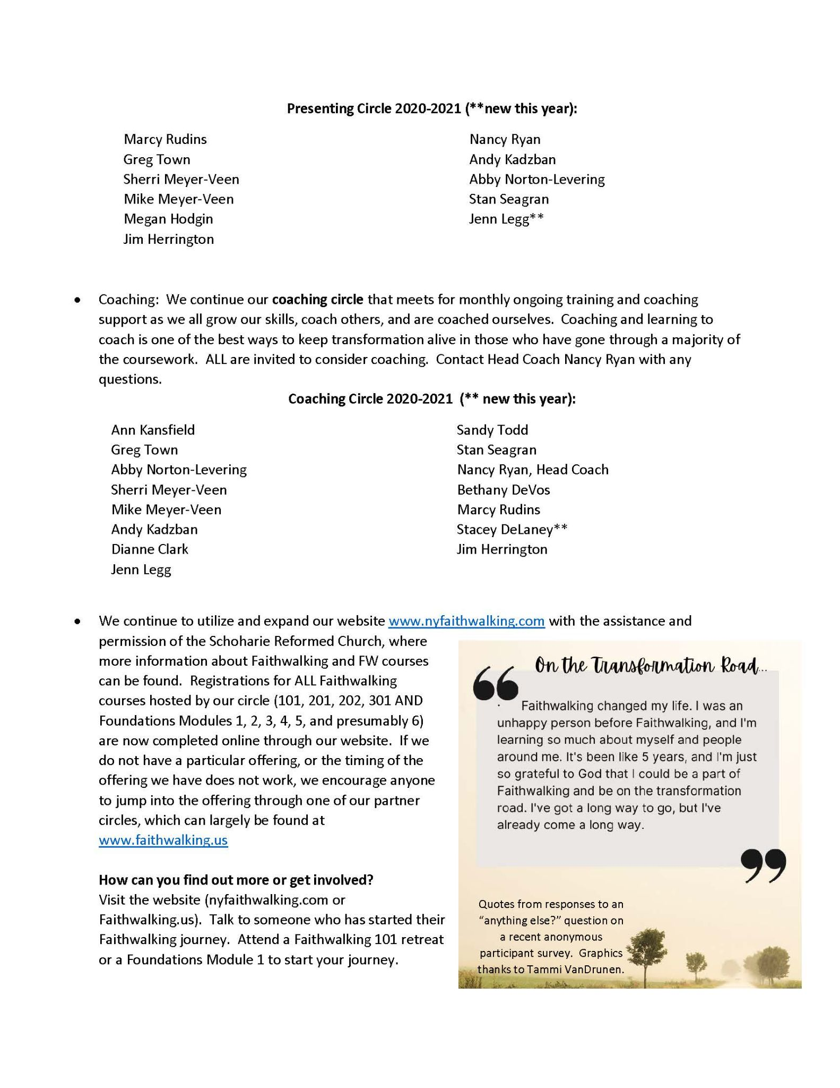
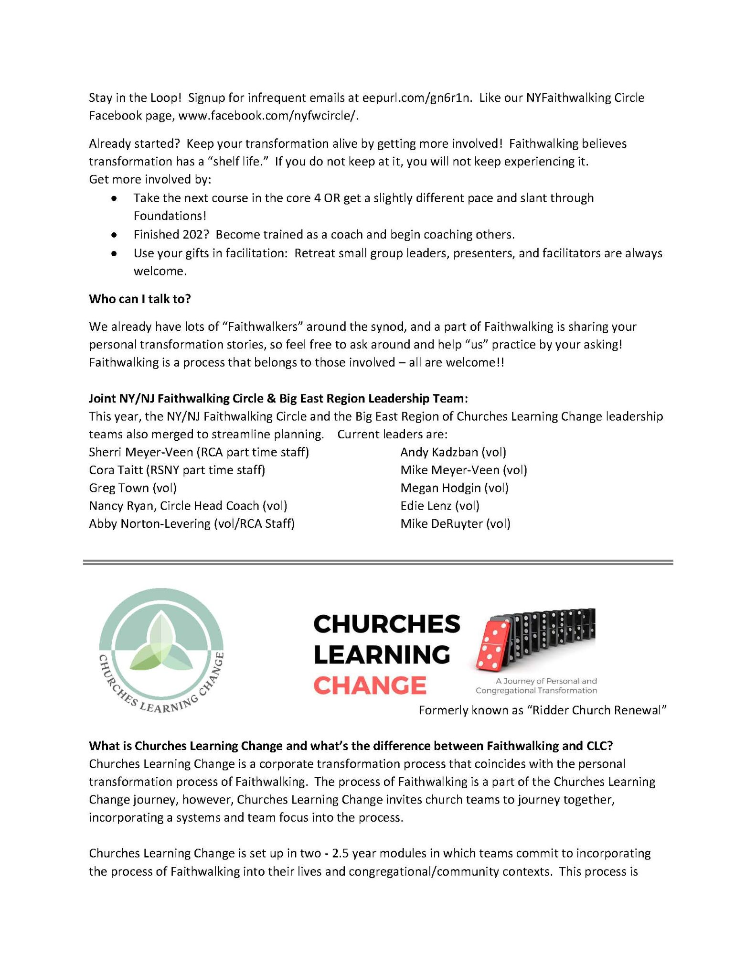
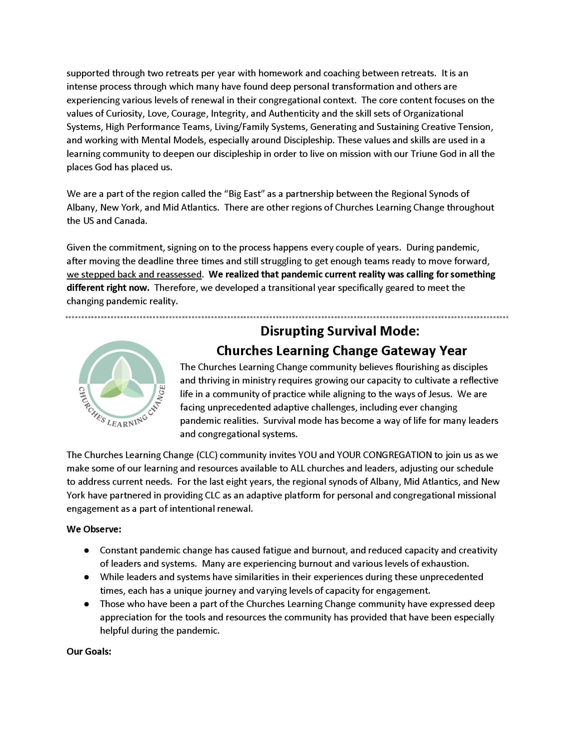
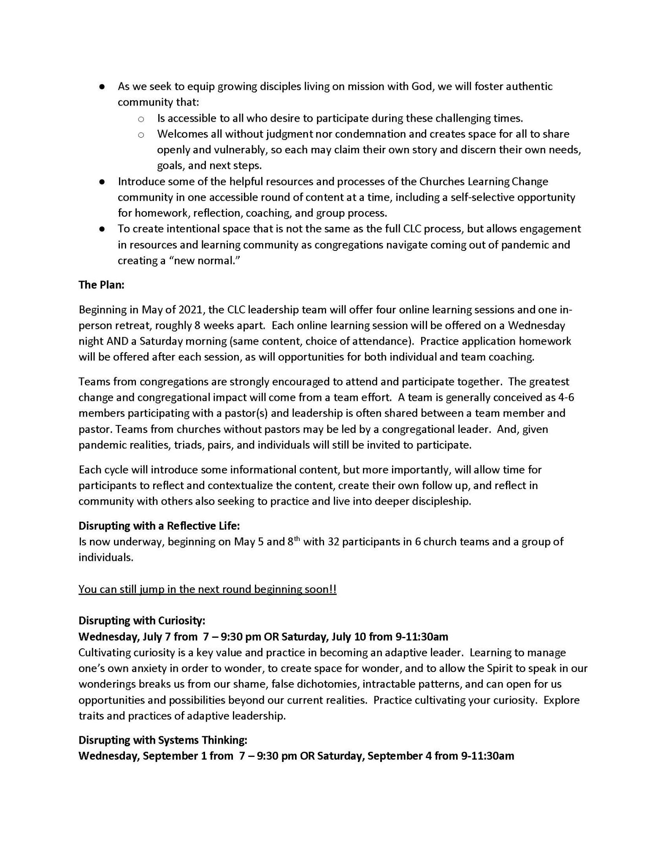
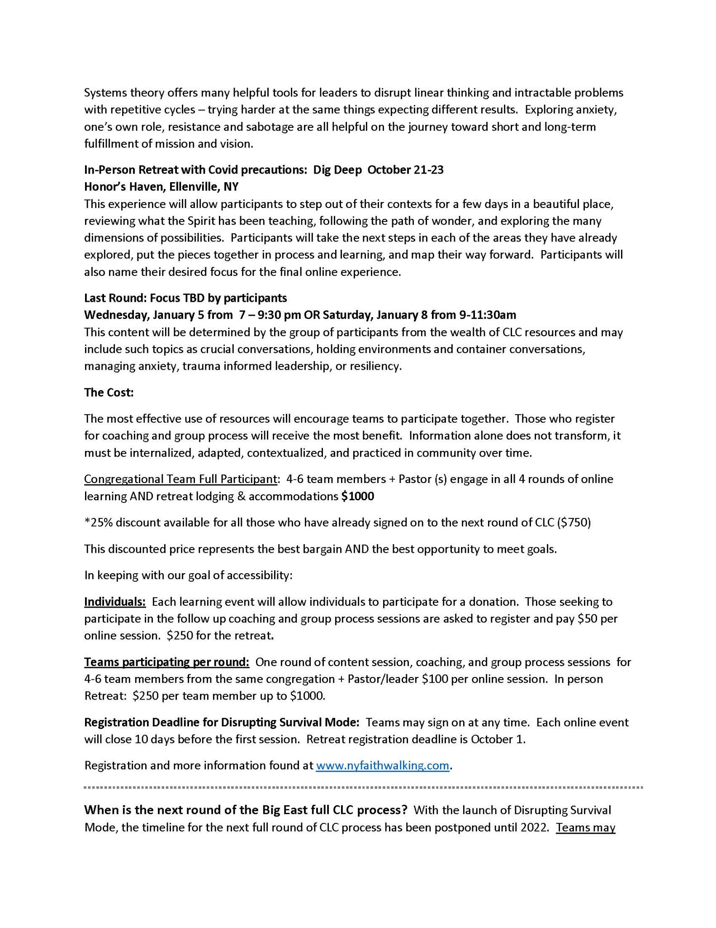
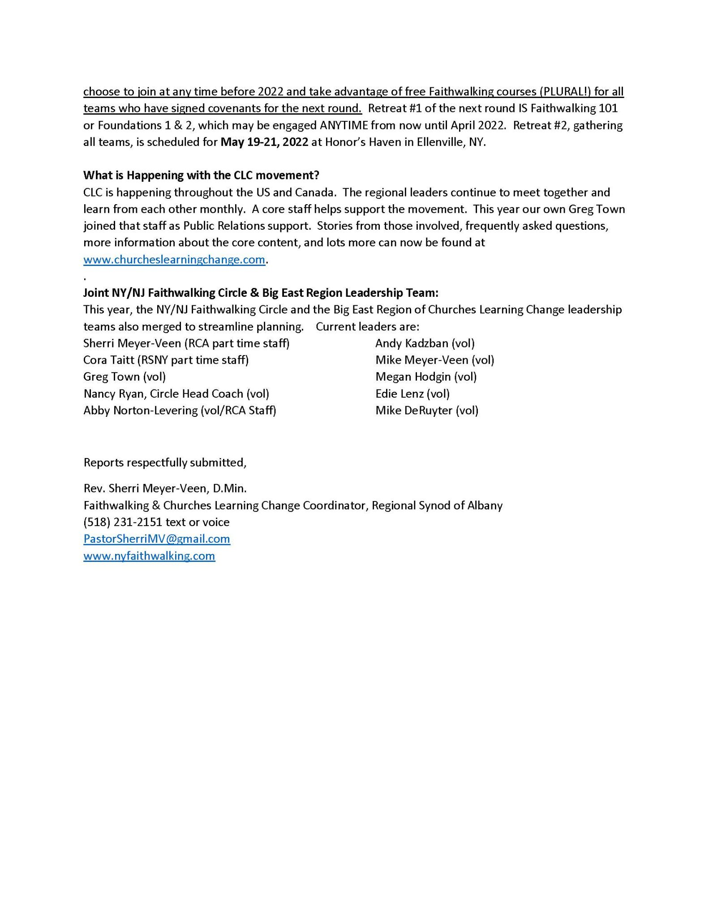
Report of the Albany Synod Fellowship Program
to the Regional Synod of Albany
April 2021

The Albany Synod Fellowship Program (ASFP) seeks to provide an intentional and transitional program of preparation for ministers serving congregations within the Regional Synod of Albany. This program accomplishes this purpose by supporting new ministers to learn to lead adaptive change and grow into their pastoral vocation. In addition, this program seeks to facilitate mutual ministry in congregations alongside the pastor.

This past year two fellows, Rev. Alisha Riepma and Rev. Matt Rogalski, have participated in the second year of the two year fellowship program. Alisha has served the congregations of Prattsville Reformed and Jay Gould Memorial Reformed in Roxbury and Matt has served the congregation of First Reformed of Bethlehem. Both will soon complete the fellowship program.

Pastoring in a pandemic has been challenging for all ministers, and for our fellows this added challenge has been put on top of their already challenging first years of pastoring. The ASFP has provided them with the support they need to navigate these challenges and successfully adapt their leadership. Support through Faithwalking, on-going coaching, a congregational support team, and additional retreats and workshops aided these fellows through the unique ministry challenges of this past year.

Fellows Alisha and Matt share the impact of the program:
….
I began the Albany Synod Fellowship Program in September, 2019. I moved out from West Michigan and took myself, my car, my dog and a U-Haul of all of my belongings through Canada and into the Catskill Mountains. This program began well and fast. It felt intense, but nice - a good change from the seminary experience. After a new year, 2020, we globally moved into one of the most intense years of our collective lives. This program helped me understand the importance of connectedness, grace and compassion. Connectedness with others and ourselves in a year of separation. Grace for the times when things fall apart. And, loads of compassion for myself and for others who are always going through more than what appears on the surface. My pastoral identity has been molded, in what I hope to be, a deeper, more steady dependency on G*d and the fact that life will always be in flux. I feel more settled and equipped in my ability to lead and accomplish tasks associated with the life of the church. I am grateful for faithwalking and the coaching I received that has helped me peel back layers of my family system as well as uncovering emotional patterns and vows. Overall, it has been a hard but life-giving experience. — Rev. Alisha Riepma (2019-2021 Fellow)

When I began my journey to pastoral ministry I felt discouraged. It seemed that every place I turned to, had no need for me. I applied to many pastoral openings and the response was an overwhelming “No!” And the primary reason was my age and lack of experience.

However, one program didn’t say no. Thanks be to God! The Albany Synod Fellowship Program invested and believed in me. They placed me in a congregation that was warm and accepting of me. The program didn’t micromanage or make unrealistic demands. Instead they equipped me for whatever comes next. And I am excited to report, thanks to my 2 years of experience, a church has extended a call to me. My journey that started with feelings of discouragement now has turned to joy and gratitude.

I am so grateful and have been deeply blessed by this program. May many more be blessed by it as well. --- Rev. Matt Rogalski (2019-2021 Fellow)

The Albany Synod Executive Committee granted approval for another cohort of fellows for 2021-2023. Currently (as of April 23), both potential fellows and ministry sites are being interviewed, and as of the Regional Synod meeting date, the admissions team hopes to be in the process of matching fellows with ministry sites. Over the summer contracts will be finalized once matches are agreed upon by fellows and ministry sites. The program will officially begin September 1 for the 2021-2023 cohort of the Albany Synod Fellowship Program.

It is also the intention of the program team that ministers in their first call within Albany Synod (and possibly beyond) will be able to participate in the programming of the ASFP. The cost of participating will be the responsibility of the minister and the congregation. More information will be forthcoming from the ASFP coordinator.

Much thanks goes to our program team, who has helped to oversee the programming of the ASFP. In the face of a challenging year, they have worked hard to adapt the program to fit the components of the program with the need to transition much of ministry and ministry support online. Retreats have been held virtually, content has been shifted, and difficult conversations have been held regarding how best to support our fellows and their congregations.

The program team includes:

- Lindsey De Kruif, Albany Synod Fellowship Program Coordinator
- Abby Norton-Levering, Synod Ministries Coordinator
- Bob Hoffman, Synod Administrator
- Sherri Meyer-Veen, Faithwalking & Churches Learning Change Coordinator
- Jim Herrington, The Leader’s Journey
- Chris Vande Bunte, Minister of the Delmar Reformed Church, mentor pastor in the 2017-2019 cohort
- Mary Jane Brown, Elder at First Reformed Church of Bethlehem, member of fellowship support team in the 2019-2021 cohort

The ASFP continues to do good work in supporting new ministers transitioning from seminary. We are grateful to the Regional Synod for their continued support of this program and are looking forward to welcoming a new cohort of fellows in the fall and seeing where God calls our current cohort of fellows.

On behalf of the ASFP team,

Rev. Lindsey De Kruif
Program Coordinator

Report from the Albany Synod Mediation Team
June 5, 2021

The Rev. Janice Fitzgerald left her position as Albany Synod Mediation Team Coordinator in March 2020. Due to the onset of the Covid-19 pandemic, at the recommendation of the synod personnel committee, ASEC decided to not fill the position for the time being. Volunteer members of the team have picked up the various responsibilities of the coordinator, to ensure that the team continues on even without a paid staff person. We take turns running the meetings and leading continuing education discussions.

During 2020, the mediation team continued to meet on a near-monthly basis. We decided to focus on building relationships among the members of the team and building our skills for mediation. We conducted a survey among our team members to see which topics felt most urgent for us to learn or relearn. The top topics included “Facilitating Restorative Circles”, “Facilitating difficult conversations”, “Doing mediation in the context of friendships and relationships”, “How to quickly present Systems Theory” and “How to get people to the mediation table”. As the pandemic wore on, we added a new item to our list: “How to adapt mediation and facilitated conversations to the zoom environment.” Over the next year, we had lively conversations about some of these topics (and some still remain on our to-do list).

The Albany Synod Mediation Team understands itself to be a resource to classes and their committees that oversee churches and pastors, and will not work with a congregation without the knowledge and acceptance of classis leadership. During the course of 2020, the team did provide support to and facilitate difficult conversations for several churches within the synod bounds.

During this ongoing pandemic, recognizing that many congregations within the Regional Synod were struggling to have challenging conversations about protocols for safely gathering (or choosing to gather virtually), the mediation team created a discussion guide to be used by consistories and Covid response teams. That useful document can still be downloaded from the Albany Synod website.

The Albany Synod Mediation Team members have all been trained by the Lombard Mennonite Peace Center in conflict mediation. Those participating in 2020 include:
Kay Grosch, elder, Schenectady Classis
Joan Garner, elder, Columbia-Greene Classis
Abby Norton-Levering, Synod Ministries Coordinator
Bob Hoffman, Synod Administrator and Clerk
Paige Convis, pastor, Albany Classis
Brian Engel, pastor, Montgomery Classis
Rick Behan, pastor, Albany Classis
Lindsey DeKruif, pastor, Schenectady Classis

The Albany Synod Mediation Team receives funding from the Synod Ministries Board for training of its members and for its events, and it remains accountable to them. It is a synod-sponsored resource to the churches and classes of Albany Synod. We can be called upon to mediate conflicts, facilitate difficult conversations, as well as to provide training on healthy communication skills. More information about services the team provides can be discovered on our page on the Albany Synod website.

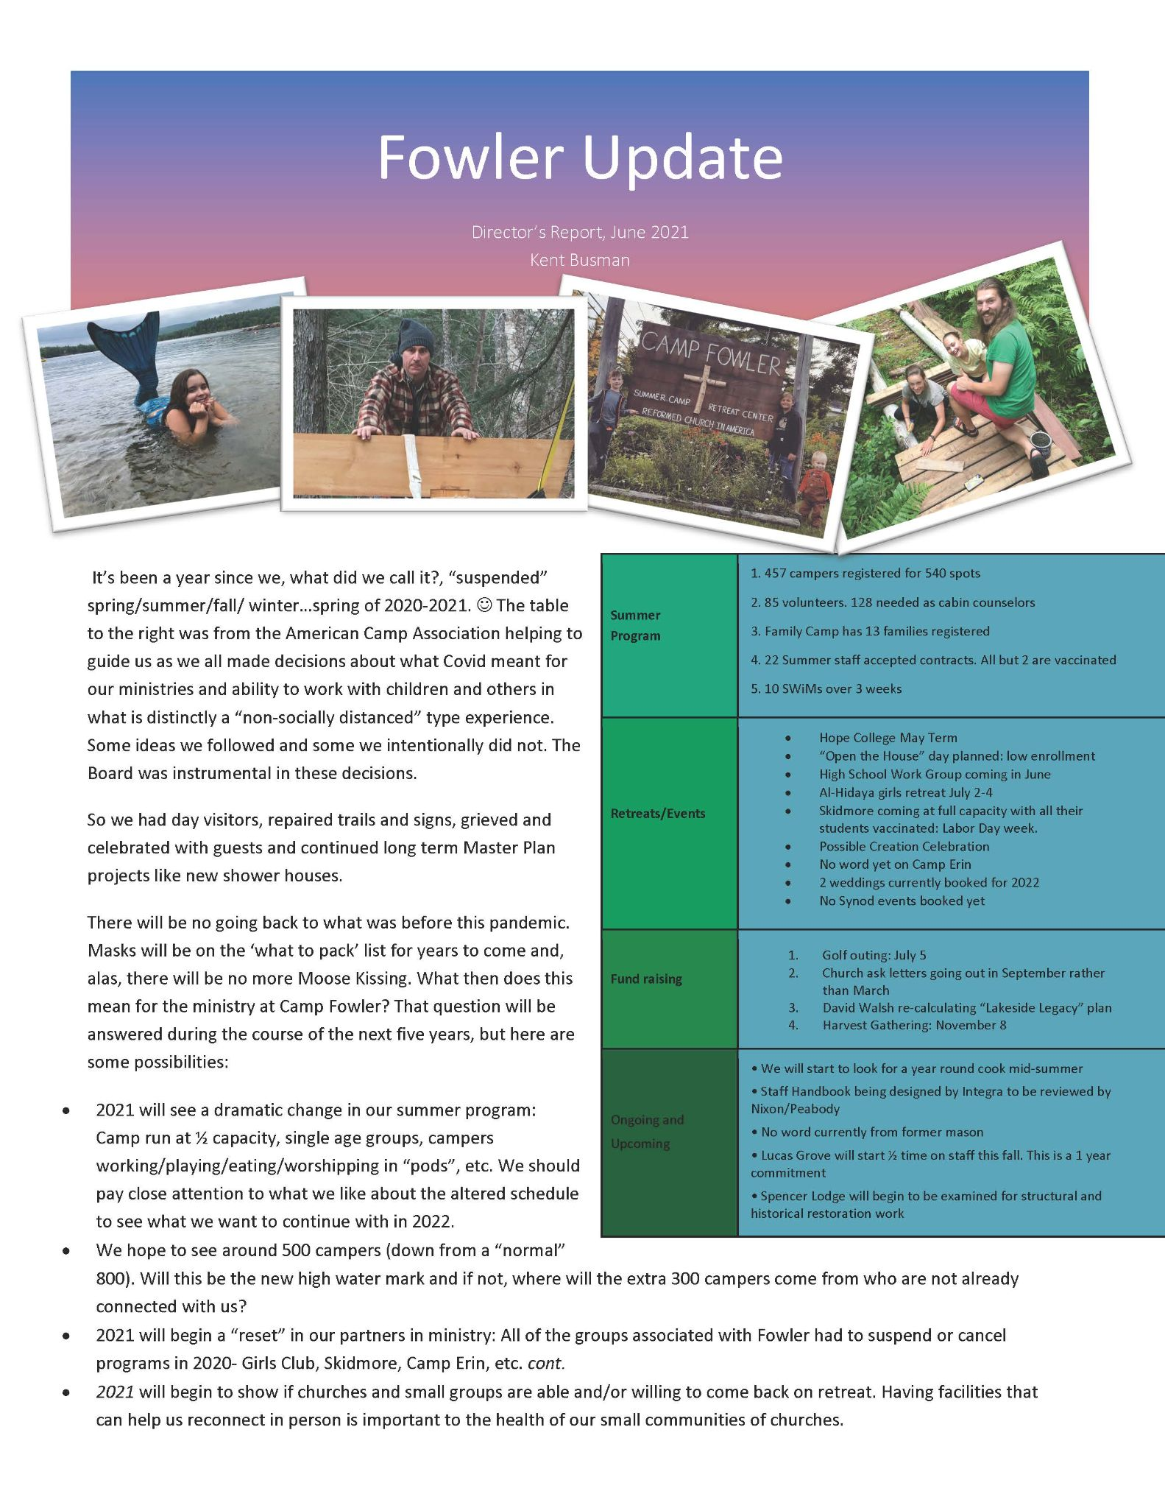
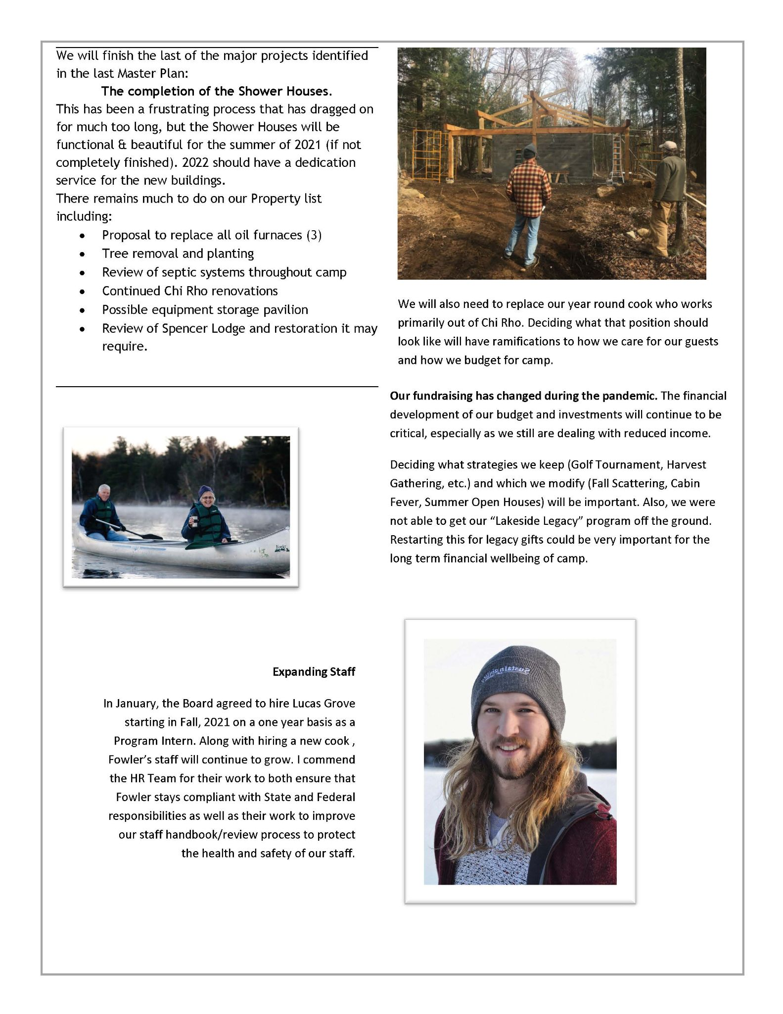

GSC Report to the Reverend Synod of Albany 2021
“These things I have spoken unto you, that in me ye might have peace. In the world ye shall have Tribulation: but be of good cheer; I have overcome the world”; These are the words Jesus spoke to his disciples as recorded in John 16:33 (KJV). Jesus warned that times of Tribulation will come and so they have. We are living smack dab in the middle of a worldwide Pandemic while at the same time dealing with violence and mass shootings in our streets, families and individuals struggling to make ends meet, students in school struggling to learn online, mental illness on the rise, self-hurt ideation, the inability to see loved ones or visit the sick in hospitals, and on and on I could go. Considering all that I have just listed and some I did not, what is our denomination spending the majority of its time on? The Vision 2020 Team report and whether or not churches and classes will remain in the RCA.
I certainly do not want to suggest the Vision 2020 Team report is not important and I definitely do not suggest conversations around LGBTQIA+ belongings in the RCA are not important. I do suggest that these are not the only things we should be spending our time on as a Denomination. To be fair we have spent time talking about matters related to the greater church. But the majority or deeper conversations were centered around the Vision 2020 Taskforce report.
When it became clear to us that General Synod 2020 would not happen because of the Pandemic, we asked Eddy Aleman, our General Secretary, to begin thinking about how the staff and the denomination might be affected if General Synod acted on any of the three recommendations. This was to be reported back to the General Synod Council only. The Council felt it was important to be prepared and so we also talked about forming an implementation team to be ready to take whatever General Synod decided regarding the Report from Vision 2020 Team. It was our expectation that this team would be formed sometime closer to when General Synod happens so they could get to work immediately once Synod ended. There was no expectation that this team would begin working on anything prior to the meeting of General Synod.
Eddy did what we asked and presented a report which he entitled “God’s preferred future”. These were his thoughts on how he envisioned the staff and denomination would fare if one of the three recommendations were adopted. There was no mention of “marriage being between a man and a woman” in his report to us. We discussed briefly that report with the understanding that some of that would be part of Eddy’s report to General Synod when it would meet in 2021. Somewhere along the way that Preferred Future report was made into a document and sent to someone in one of the classis in the MidWest (I believe) and then it was shared to the denomination. This was not done with the direction of the GSC. We met in March to have a conversation regarding that.
During the same time GSC members started receiving emails about both the preferred future document and that there were some GSC officers, GSC members and the General Secretary who were joining or meeting with groups that are talking about leaving the RCA. There was a strong feeling that those who were joining these groups that are actively discussing and/or in the process of leaving the RCA, that these GSC members should not be involved in making decisions about the future of the RCA. Additionally, there was a statement in the Preferred Future that talked about the RCA remaining faithful to its historical position that marriage is between a man and a woman. The email proved to be a surprise to many of us on GSC.
It would have been nice to have been given a warning that this would happen as many who wrote the email are members of Albany Synod. Unfortunately, I was blindsided and other GSC members assumed I knew this was coming. Needless to say, we convened a special meeting to talk to and hear from all the members of GSC that were mentioned in the email. We also recommended removing the “God’s preferred future” document from the RCA Website.
We are hoping to have General Synod sometime this year where we can gather and discuss the Vision 2020 Team recommendations. Jesus told the Disciples that in this world they will face tribulations and boy did they; and so are we. Yet I love the next words in John 16:33 where Jesus said “but be of good cheer, I have overcome the world”. I have one more year to serve as Albany Synod representative on GSC and I count it an honor to serve. My term has been filled with heart aches and tension. I am certain rocky times are still ahead. Challenging times will continue to come. Beloved, know that I take solace in knowing that Jesus is still overcoming this world!
Respectfully Submitted
Rev. Kent A. Mc Heard
The Reverend Albany Synod’s Representative on the General Synod Council

NEW YORK STATE COUNCIL OF CHURCHES

The New York State Council of Churches, founded in the late 19th century, represents 7,000 congregations across the State of New York. We are composed of eight partner denominations including American Baptist Churches USA, The Episcopal Church, Evangelical Lutheran Church in America, Presbyterian Church USA, The Reformed Church in America, The Religious Society of Friends, United Church of Christ, and The United Methodist Church.

The New York State Council of Churches:
- Certifies and supports Protestant chaplains in the Department of Corrections and Community Supervision, Office of Mental Health, and Office of Children and Family Services as they seek to offer love and hope to so many who feel hopeless and have had little experience of being loved unconditionally. We urge fully ordained pastors, including those who may be serving as parish ministers, to consider applying for certification. The Departments of Corrections, after a state hiring freeze, will resume interviews of candidates to fill at least 12 chaplain openings. In October, we held our annual chaplain’s conference virtually which can be viewed at WWW.NYSCOC.org.
- Advocates for laws and policies, consistent with our denominational partner’s social principles, which address structural racism, economic inequality, and environmental degradation.
- With the advent of the pandemic, the Council sought to synthesize all of the public health guidance for congregations. We also engaged in rigorous advocacy for the state and Federal governments to address the economic impact and racial disparities. Our guidance appeared on the New York State website. We now continue to advocate for just distribution of the vaccine. Central to our efforts have been to consistently call on the very wealthiest New Yorkers to contribute more to address severe state underinvestment in social services before and during the pandemic including cuts to drug and alcohol programs, home care, Medicaid, education and infrastructure budgets. We also advocated for increased Federal aid.
- Our Statewide Ecumenical Advocacy Day took place virtually on February 25. We focused on raising additional revenue for the state budget, support for the Climate and Community Investment Act, expansion of funding for affordable housing, prevention of cuts to long term care, and multiple reforms to ease the process for people re-entering society from prison. The full description of our 2021 legislative asks and video of all the presentations can be found at WWW.Nyscoc.org.
- Promotes mission consistent development of church property. The Council and three other partners--Interfaith Assembly on Homelessness and Housing, Interfaith Affordable Housing Collaborative and Bricks and Mortals--received a generous grant from Trinity Church Wall Street to help us consult with congregations in New York City about repurposing their property to build affordable housing. We also offer grants and assessments to congregations outside of New York City seeking to develop their property. Our Who is My Neighbor Seminars offer expert guidance. Seminars can be found at WWW.Nyscoc.org.
- We partner with the Federation of Indian American Christian Organizations to champion religious freedom and human rights in India. Our advocacy work has been complemented with monthly webinars. We continue to strengthen bonds with our partner, the Church of South India.

We thank our denominational partners for their support. You can view our virtual fundraising event which tells the full story of the Council on our website. WWW.Nyscoc.org.
Our new offices are near the capitol at Westminster Presbyterian Church - 85 Chestnut Street, Albany, New York, 12210. Office email is nyscocalbany@gmail.com phone is 518-436-9319.

The Reverend Peter Cook is the Executive Director and can be reached at pcook@nyscoc.org or 508 380-8289.
The Reverend John Paarlberg is the Synod of Albany representative on the Executive Committee and can be reached at jpaarlberg@gmail.com or 518 462-6040.

- PRESIDENT’S REPORT
Rev. Paige Convis

In the absence of the Vice President, Rev. Kent Mc Heard, Immediate Past President, assumed the chair while the President, Rev. Paige Convis gave her report. Along with President Convis, Rev. Abby Norton Levering presented her report to the synod. They shared a dialogue about some of the life learnings and ministry applications of the past year with the impact of the pandemic. They noted what was halted by the pandemic and some of the losses experienced because of it, the ongoing work of ministry that was done in congregations, classes and the synod, and some of the ongoing challenges we all face because life and ministry is ever changing. The called attention to the Report of the Synod Ministries Board which exemplified how the synod remained ‘in this together for good’ all through the pandemic and continues to do so beyond it.

In concluding their collaborative report, they invited the delegates to role playing a scenario where adaptive change could be used to solve a congregational situation.
Grace and much peace to the Reverend Regional Synod of Albany. I begin my report to you with gratitude for your openness, creativity, love and candor. Before my service as President, I felt the Regional Synod of Albany as home for me, but after these 2(!) years, my heart is filled with gratitude for the opportunities to learn, grow and effect change in our region. We are a people who are passionate about the mission of God in this world and work tirelessly to bring it about—this is inspiring!
I would have never guessed at the many events that have occurred since my election to Vice President in 2018. I admit that global pandemic wasn’t on my list of “things that could happen.”
I have witnessed the immense amounts of resilience, creativity, love, compassion and gumption demonstrated by the churches and leaders in our region. In a time when being together physically was not the wisest decision, we found ways to keep ministry going—the Word of God preached, people fed and clothed, and the light of God shone in our communities. I am truly inspired and proud of the stories.
Now, we all know it all hasn’t been a pocket full of roses. It has been HARD to adjust to the changes. The church was already amidst change, and then we are whacked over the head with pandemic adjustments too. All of this makes for some grumpiness.
Grumpiness is usually grown out of the lack of capacity to hold all the aspects of a situation together in one’s mind. For example: when you are hungry. We are often easily set off when we are hungry because we cannot at the same time manage the annoying thing, the crying child, the long line at the store—the space in our mind and body that our empty stomachs take up is just too much.
Grumpiness is at the core of what it means to be human in many ways. I am not bashing grumpiness. What I have noticed is our (as humans) lack of capacity to hold different aspects of life together in a way that feels life-giving and whole. We see this most clearly in deep divisions that have become a part of the wider culture, in politics, and now the Church. Disagreement is not bad, and it is not contrary to God’s plan. It does, however, take up a lot of “space” in our lives and it causes me to wonder “what is another way?”
So, is this a call to unity? No. Those are often seen as insincere and filled with empty words that live in a reality that seems far off. Instead, this is a call to something else: Shared vision for the future.
The Church Universal is in a bit of a time of transition. It was in a bit of a transition before COVID-19 and it seems that the pandemic has forced us to ask questions that we didn’t even know we had to ask. But we still find ourselves mainly in the same place—searching, wondering, and trying to figure out how to do ministry in the year 2021.
There is this exercise that I am going to invite you into today. I have used this before, but it seems fitting for today. If you were given a magic wand and you could wave it and change ONE thing about the current reality of your Church or ministry location, what would it be? This is usually the thing is most important to you (at least in the moment). If I had a magic wand and I could wave it and change one thing about the current reality in the Regional Synod of Albany, it would be to have a shared vision of ministry.
Now remember, this isn’t a call to unity, so whatever do I mean? Does this change the way we act? What are we doing? If there is more or less urgency to our message, would our faith be stronger? Maybe. My hope in waving the magic wand granting us shared vision would be that we could get clear on things that need to shift and put our minds and best resources into making that happen.
Here in the Regional Synod of Albany we are all too aware of the struggles of doing ministry in 2021 and that the complexities of our diversity can seem too much to handle. The junction between culture and religion, where and how to shift, where to stand in tradition and when to let it go isn’t an easy job.
I heard on the radio the other day—the 1995 Joan Osborne song—One of Us. She poses the question—What if God was one of us. The message of this song is quite thought provoking, but it’s just that one question that really stood out to me as I sat down to write this report—What IF God was one of us? If God was walking among us right now, living this pandemic, seeing the church in action (or inaction)
What vision could God be bringing to us? How does God stand amid such division and confusion?
Now we are lucky (or is it providence?) that we have SOME clue, after we were gifted Jesus, who did indeed walk among us.
But I am not sure what it would be like for God to be one of us today—but my best guess is that to get closer to that shared vision means that we take time to discern it, to do serious work around adaptively changing our ways of being together, the way we do ministry, and even (dare I say) the way we understand The Bible.
I often find myself wishing that God could wave that magic wand and make that all clear. But for now, there is no magic and we are left to our devices with only guidance from the Holy Spirit.
In last year’s report that I did not formally give I highlighted all the places where classes and churches and even the Regional Synod were needing to ask questions of themselves. Those places where we needed growth and help. I am excited to be launching The Adaptive Change Task Force to help navigate those questions.
Like us, God would have strong opinions. God values some things over other things, and surely God would bring a specific set of gifts to every situation.
This likness, it is a gift for us to celebrate, claim, and when it does not make sense, to wonder through together.
We are excited to be launching a task force that has differing views, that will spend time learning and growing, reflecting and putting forth ideas for our shared life together. The goal of this Task force is to help us to adapt to the ever-changing world around us, the church and her place in the world, and to listen to what God is saying to us amidst the deep conflict that is happening within our denomination.
So perhaps this task force will call us to unity—for it will help us to unite around shared values and to step into this time of transition with creativity, grace and openness to God’s movement among us. God isn’t one of us (thank goodness), but does invite us into the mission of God in this world.
I wonder what we will hear!

Synod Ministries Coordinator Report to the Regional Synod of Albany
Rev. Abby Norton Levering
Every year when I write this report, I give thanks to my colleagues with whom I have the great pleasure to collaborate. Bob Hoffman, Ali Stone, Sherri Meyer-Veen, Lindsey DeKruif and Sandy Cornwell are all amazing, committed, and creative. Our zoom staff meetings are a highlight of my month. The rest of the synod staff provided stellar help and coverage for me when I was out for a significant chunk of the fall on maternity leave. I am most grateful to them all for their loving, careful support.

I’m giving special thanks this year for AC Reilly and the tremendous work she’s done as the Albany Synod Communications Coordinator over the past six years. Reilly shepherded synod communications (website, e-newsletters, social media, not to mention legacy modalities like snail mail appeal letters and trifold brochures) during years of transition. She not only did good technical work, she also supported the synod in having challenging conversations about the how, the why, and with whom we communicate. Her friendly competence and creative can-do attitude really helped the synod inhabit the new digital age with flair and fun.

Reilly ended her tenure with Albany Synod at the end of 2020, and we have been searching for her replacement. By the time this report is published, we hope to be also broadcasting the name of our new synod communications coordinator!

My report stands alongside the reports of the Synod Ministries Board, as well as the reports on Churches Learning Change, Faithwalking, Albany Synod School of Ministry and the Albany Synod Fellowship Program. Most of my work is intertwined with these efforts. My work is inherently collaborative--I truly spend my days coordinating the efforts of many brilliant people, assisting in communication among them, providing resources and support to them, and then communicating with the greater RCA and the church at large about what’s happening in Albany Synod.

2020: A Watershed Year

Given the pandemic reality the US faced in 2020, Albany Synod shifted as much of its ministry as possible to virtual settings. Meetings, activities, retreats and trainings all moved online. For programs which already functioned to some degree in a virtual space, like the NY Faithwalking Circle and the Albany Synod School of Ministry, this transition felt less jarring. Other groups made the transition beautifully, like the monthly Christian Educators Group--they experienced new life as new members participated more regularly in the more accessible online space. For the first time in its august history, Beginning and Beyond, the synod’s annual retreat for clergy new to their ministries, happened in a zoom meeting. Its theme of Naming and Addressing Collective Trauma was nevertheless deemed helpful by its attendees. Still other events were sorrowfully cancelled or postponed, because they could not meaningfully translate to an online setting (like the yearly Pastors+Families Retreat). Albany Synod staff and leadership put a great deal of energy into helping churches sort out their options for socially-distanced in-person worship, as well as virtual worship, meetings and mission. For example, the Synod Mediation Team put together a wonderful discussion guide for consistories and Covid-response teams to use when having conversations about whether and how to move to virtual worship or to return to in-person worship (this wonderful guide is still available on the mediation team page on albanysynod.org!) We also provided opportunities for people to process and learn about grief, anxiety and resiliency with friends and colleagues across the synod. Finally, we hosted a couple meetings to hold space for synod folks to learn about and discuss denominational issues and the RCA’s 2020 Vision Task Force Report. I and the rest of the Albany Synod staff have been very busy this year, and we are tired, just like the rest of you.

As a participant-observer in the rapid change still occurring across our synod because of the Covid-19 epidemic, I was both heartened and alarmed, both surprised and unsurprised by the responses of our churches to the stresses the pandemic put on their systems. The pandemic highlighted and accelerated changes already occurring in our churches. It's worth noting that with only a few rare exceptions, membership in our classes has decreased every year over the past few decades. Of course, membership numbers is not the only metric that matters, nor is it on its own an accurate measure of church health. However, it is a metric that could impact the financial stability of Albany Synod and the existence of its own ministries. Another measurable factor that directly impacts the capacity of the synod and classes to get their work done is the number of pastors employed in proportion to the number of churches in each classis, and this number has decreased noticeably in the time I've been serving Albany Synod, and more steeply over the past year.

The standard mental model of a “successful church” which has operated in a mostly unconscious way across our synod looks something like this:
- it exists as a standalone congregation with its own consistory
- it employs a full-time minister
- it operates an independent ministry out of a church building that they own and maintain
- it sustains itself with funds that they raise from tithes and gifts from their membership (or from well-managed endowments)
- ministry is understood primarily as caring for the needs of members of the church
- mission is understood primarily as work by missionaries in foreign lands, or as charity for less fortunate people in the community

The standard mental model of a successful church has been breaking down for a long time now, and the pandemic has accelerated the disintegration process. In order for the church of Jesus Christ to live and thrive, we must tackle the urgent, overdue task of questioning every aspect of the standard mental model of church, and developing new models of ministry. For some of our churches, the pandemic has provided the impetus to creatively re-imagine their models of ministry. It is imperative that the hardwon insight gained not be lost in the longing for a return to normal.

Adaptive Change, Redux

Over my time as Albany Synod Ministries Coordinator, the synod has continued efforts to assist churches with their technical challenges--problems for which there are known resources and existing solutions. We have also faithfully sought to serve as a holding environment and an arena for experimentation in addressing the many adaptive challenges before us.

One simple way to understand the differences between technical and adaptive challenges is this: the solutions for technical challenges can be found “out there” (in books, on the internet, or spouted by helpful church consultants) but the solutions to adaptive challenges can only be found “in us.” In other words, as activist Glenn E. Martin says, “Those closest to the problem are closest to the solution.” There are no short-cuts or silver bullets. Only the people with the problem can discover new ways forward, through adaptive challenges, through introspection, prayer, discernment, dialogue, experimentation (which often includes failure as a part of learning), loss, grief, and the unexpected joy of new life.

In preparing to write this 2021 report, I reread all my reports to Albany Synod from the past few years and discovered that in every report since 2017, I have talked about the need for adaptive change in our churches and classes. In 2018 I wrote about the differences between technical and adaptive challenges:

An adaptive challenge...has no straightforward solution, and is by definition difficult to address because solutions must be developed. If technical challenges ask us to try new ways of doing things, adaptive challenges call us to new ways of being…[and] require us to ask open-ended questions, try experiments, and learn from failure. One such adaptive challenge is the question of how to be a cohesive, functional synod in an era when denominational loyalties are breaking down, and when our extreme polarized political climate affects every aspect of how we categorize people and problems.

This statement feels more true to me than it was before, within the context of the pandemic and the RCA Vision 2020 Task Force process.

This past year our synod churches were presented with the rare, shared experience of the Covid-19 pandemic, and the common need to shift our mental models: how to conceive of ministry when we cannot possibly continue with business as usual? Our extreme political divides and urgent demands to address the church’s history of racism, sexism and homophobia raised additional adaptive challenges. Multiple technical challenges were also presented: how to use technology appropriately to do worship, meetings and mission when people cannot be gathered in person?

In my conversations with pastors and church leaders throughout the pandemic, I observed that the mix of many hard challenges was both exhausting and exhilarating, as congregations reacted in the various ways that anxious systems do when they are stressed:

- Some congregations simply worked harder and harder until they reached the point of burnout. The pastors and leaders of these churches appear to me to be walking wounded, and our synod and classes have the opportunity over the next few years to support the rest, rejuvenation and healing of these folks.
- Other churches ignored or minimized their challenges, or shut down, both literally and figuratively. Their sense of community within their congregations and/or with their classes disintegrated. My expectation is that these congregations will struggle to regain the momentum and drive to do ministry in a post-pandemic world.
- Other congregations turned to fighting amongst themselves, while still others turned up the “us/them” mentality and fought the systems they perceived as restricting them unnecessarily (for example, a few Albany Synod churches never stopped worshipping on Sunday mornings, even though the state government and common sense recommended a temporary halt to in-person gatherings).

At the same time, many of our congregations rose to the occasion, shifting worship and other gatherings to virtual settings, experimenting with new technologies for worship and mission and creatively fostering new ways of connecting and communicating. People had endless zoom conversations which felt hopelessly awkward until they gained confidence in themselves and others. They learned to make donations online, developed new sets of manners for online venues, struggled to better read emotions in other people’s eyes, and found new ways to feel close to friends and colleagues, even when they were physically far from one another. They were surprised, over and over, by how God could work transformation in their lives through these new modalities.

A New Adaptive Change Taskforce

In October of 2020, the Albany Synod Fellowship Program (ASFP) Planning Team submitted a report to Albany Synod Executive Committee, detailing their findings of their self-evaluation process and requesting that funding be granted for another round of the program (2021-2023). The report contained a very important observation, that while some Albany Synod congregations are engaging in adaptive change processes through participation in the ASFP, through Churches Learning Change, through other denominationally-sponsored activity, or through other self-discovered means, many Albany Synod congregations are not meaningfully engaged in this necessary work. Meanwhile, our classes continue to struggle to function healthily, to even get the basic work done that is required of them by the Book of Church Order, so they don't have the energy or resources to support churches in doing the hard work of adaptive change. In the meantime, appropriate denominational resources continue to dwindle due to ongoing conflict.

Therefore, the ASFP program team recommended that a new task force be formed to explore new methods by which Albany Synod could support ALL its congregations in the work of adaptive change. ASEC approved the formation of this task force. We hope that the membership of this task force will be finalized and publicized at the annual meeting of the Synod of Albany on June 5.

The directions that this new Adaptive Change Task Force will take are yet unknown to us, because the task force will need to meet and engage in discernment to develop their own priorities and to outline their work. My hope is that they will find ways to creatively draw many other people into their discernment and work. This is a big lift, and much energy will be required. In many ways, it feels to me like this Adaptive Change Task Force is the “In This Together For Good Task Force, The Next Generation.” The ITTFG Task Force did a lot of good work which led to the writing of Albany Synod’s Supervision Handbook, the Fellowship Program, and the Albany Synod School of Ministry (among other things). It fostered many good conversations at the classis level. But much more needs to be done, and my hope is that the Adaptive Change Task Force will take it on.

Finally, I must note that the work of the Adaptive Change Task Force is unfolding under the shadow of much unrest in the RCA at large. It is unclear, as of yet, what will be the outcome of the 2020 Vision Task Force process and report. Many people who are smarter than I am have predicted that no matter what happens at the next General Synod meeting, a sizeable chunk of the RCA will leave our communion, over what they perceive to be irreconcilable differences. Sometimes I feel anxious about whether a smaller denomination can continue to function effectively in our current reality; at other times, I feel at peace with the possibility of a smaller denomination that grows its capacity to do conflict in a more transparent and fruitful way.

It’s difficult to make predictions about what will happen in Albany Synod. However, I do know that many people in Albany Synod value local classis and synod relationships highly and will want to preserve them, whether or not we can convince one another to come around to our own point of view. Loss lies ahead of us, inevitably. The questions are: will we be mindful and mature as we mourn and grieve? Will we lean into self-differentiation as we cope with our losses? I remember again that our motto in Albany Synod is that we are “In This Together...For Good.” We are together for good both because we choose one another as companions on the way, AND because God, in Christ, through the Spirit, brings us into a unity that we can’t create on our own.

Respectfully Submitted,
Abby Norton-Levering, Synod Ministries Coordinator

SYNOD MINISTRIES BOARD REPORT
Rev. Marcy Rudins, Chairperson
The Synod Ministries Board of the Regional Synod of Albany (SMB) met March 5th, June 9th, September 17th, and November 19th 2020, and January 28th and April 15th, 2021. Members of the SMB participated electronically in the meetings via ZOOM.
The mission of the SMB is to “coordinate and exercise oversight of resources and program support of the Regional Synod of Albany.” Practically, one of the roles of the SMB is to have an “ear to the ground” to then implement change and ministry opportunities for those within the synod.
This year has been particularly interesting, as with so many organizations and teams, during the COVID-19 pandemic. However, even in the midst of so much grief, pain, loss, and anxiety- the SMB continued to meet and offer opportunities for the church at large to grow in mission, revitalization, and discipleship.
The Synod Ministries Board has supported and provided such opportunities:

School of Ministry: These series of courses that range from Old/New Testament to Standards to Preaching, provide training for those who are interested in pursuing to be preaching elders, commissioned pastors, or those who long to learn. These have been wildly successful, even during the pandemic, with online classes. The first round of students to have completed all of the courses will be graduating this year.

Sexual Harassment Prevention Training: On October 5th and 8th, the Regional Synod provided sexual harassment training that was specific for clergy and church staff, as per the rquirement of NYS. This was spearheaded to provide not only state training, but also to create space to have conversation around sexual misconduct in the church.

Christian Educators Group: While there wasn’t a specific event, as there have been in previous years, the christian educators group continued to meet online as a place of support, mutual learning, and resource sharing. The group is looking forward to meeting in-person in the coming months and for future christian educators workshops with the synod.

Faithwalking: Faithwalking continues to thrive this year with the robust online offerings and online retreats. Faithwalking foundations kicked off this year with five different modules of 10-week online courses that included teaching, coaching, and authentic community to learn alongside. The work of Faithwalking has helped the synod with language around anxiety, adaptive change, and expressing grief in loss this past year. Look into the Faithwalking report for more information on what they will be offering this year. On behalf of the SMB, we are thankful for this tool and program for each of us!

Mediation Team: The Synod Mediation team currently doesn’t have a paid coordinator, but continues to meet on a regular basis and is a resource for churches and classes. This team is for a church that has difficulty in facilitating certain conversations or is experiencing church conflict. Contact the synod ministries coordinator if you are needing to be in contact with the mediation team.

Specialized Transition Ministers: The SMB has allocated $5000 to provide scholarships for the members of the RSA classes to be trained as “Specialized Transition Ministers,” if so desired. These scholarship applications and information on the funding can be discussed with Abby Norton-Levering or Bob Hoffman.

Technology Mentors: With growing requests to have more support for online worship and technology upgrades in ministry settings, the SMB has provided a list of volunteers who are willing to work with churches to walk with them through the process of upgrading and installing technology upgrades.

SMB Functionality Task Force: Since the March 5th SMB meeting, the board has longed to have more clarity on the purpose, mission, and functionality for this group. The task force was formed, and has brought forth several recommendations that were approved by the SMB as a whole:
- Members of the SMB commit to attending a Fall retreat/in-person meeting in 2021. The goal of this retreat is to grow SMB reps’ self understanding of themselves as reliable, resourceful and responsible, each needing to participate actively in planning and participating in synod events and work.
- Work for this retreat will include:
    - writing an operations manual for the SMB
    - writing a job description for SMB representatives
    - developing goals for the SMB
    - updating the SMB mission (purpose) statement
    - Looking at the by-laws, as well as recommend the re-writing of the bylaws.
3. The SMB will also appoint an SMB Communications Improvement Task Force. This communication includes but is not limited to:
    - within the SMB (about meeting dates, expectations, upcoming programs, etc)
    - from synod to churches and classes and vice-versa
4. The SMB will hold at least one in-person meeting each year, and hold other meetings by zoom.

The work of the functionality task force will hopefully move us along to a more whole, competent, and reliable resource within the synod.
Funds Update:
The SMB partnered financially this year with Camp Fowler in the amount of $3,000. This partnership is a means of supporting their ministry, especially as the Fowler staff provided retreats up at the prayer cabin for all ministers during their “Year of Jubilee.” We are so thankful for the work of Camp Fowler and for their continued ministry.
The SMB Grant committee approved just over $7,000 in grant requests from our churches in 2020/2021. We are continuing to actively promote the grant process at classis meetings and SMB members have made themselves available to both congregations and consistories should they need assistance in completing the grant process. The grants funded are listed below:

2020
NYSCC Advocacy Days $250.00
Fort Plain- Summer Intern $1,000.00
Schoharie- Summer Day Camp $1,000.00
Helderberg- Pre School Playground $1,000.00
Greenbush-Ipads for Remote Worship $ 927.00
Samaritan Counseling Center $1,000.00
Kinderhook- Technology $1,000.00
Camp Fowler- Partnership $3,000.00
Total Grants $6,177.00
2021
Sprakers- phone/internet service $1,000.00
Fort Plain- technology $1,000.00
Specialized Transitional Minister $1,000.00
Total Grants $3,000.00

Even with all that has been going on this year and with the tremendous amount of change that we have gone through, and is still before, the SMB continues to be of support to each of you. We are thankful for the ways you have prayed for, financially sustained, and offered leadership to us this year.

May each of you experience God’s embrace and grow in grace amidst your ministries and your homes.

MOTION To receive the President’s Report, the Ministries Coordinator’s Report, and the Ministries Board’s Report with the thanks and gratitude of the synod. (CARRIED)

Kent Mc Heard thanked Paige and Abby for their creativity in presenting their reports and engaging the delegates in meaningful ways.

Kent also noted each of these reports have been forwarded to the General Review Committee for their review and advice to the synod.

VII. GENERAL REVIEW COMMITTEE REPORT
Rev. Dr. Lisa VanderWal, Reporting

Rev. Dr. Lisa VanderWal reported on the work of the General Review Committee in considering the three reports: President’s Report; Ministries Coordinator’s Report, and Ministries Board’s Report. She noted three themes that appeared in the committee’s review:
Losses and Challenges
Accomplishments and Opportunities
The Way Forward

Lisa expressed great appreciation for the good work which Paige, Abby and Marcy have presented in their reports. They give an honest expression of our current reality but do so with a vision of hope for our future together. Lisa encouraged the delegates to share these reports with their congregations and classes and be guided by them in their own way forward into what God is asking right now.
GENERAL REVIEW COMMITTEE REPORT
The General Review Committee received the three reports listed above and met via Zoom to craft a response. We received the three reports with a sense of gratitude that, the global Covid-19 pandemic notwithstanding, the RSA worked diligently to serve and resource the churches within its bounds. We commend the President, the Rev. Paige Convis, the Synod Ministries Board Chairperson, the Rev. Marcy Rudins, and the Synod Ministries Coordinator, the Rev. Abby Norton-Levering, for their fine work and reporting.
As the committee discussed the reports, we noted that they dovetail in a number of important areas. Thus, it was the decision of the committee to bring a response that harvests key themes from the reports taken together, considered under the headings of “Losses and Challenges,” “Accomplishments and Opportunities, and “The Way Forward: Where Do We Go from Here”?
Losses and Challenges
Little did anyone foresee the breadth and severity that the novel coronavirus that emerged in early 2020 would have on our world, our nation, our communities and even our churches. By mid March, 2020, most of our churches had closed their sanctuaries to in-person worship and moved worship and activities online, utilizing Zoom, Facebook Live, and other platforms so that worship, fellowship and learning could continue. Still, there were a number of losses and challenges that resulted, many from the sheer volume and radical nature of the change thrust on us by the pandemic.
1. We lost a sense of the normal, familiar, and comfortable; we had to try and do new things. This was exacerbated by the inevitable isolation caused by the shutdown.
2. There were also personal losses, with people in our individual orbits contracting Covid, some succumbing to the disease. These have been very painful losses.
3. Some lost the capacity to cope because the stress was too great or too scary, and fights and flights resulted; struggles to keep control and/or just shutting down.
4. We fear the loss of unity — or agreement — on certain things, large and small.
5. We HAD to lose the mental model of a “successful church”. This is likely a healthy loss, because now we CAN explore other ideas. This is also a challenge.
6. We did NOT lose the presence of God nor the guidance of the Holy Spirit who has opened our eyes to new ways – adaptive change – and this challenges us to stretch and grow our capacity.
7. We learned more about ourselves and our potential capacity. At the same time, we realized that some aspects of congregational life cannot be experienced on a Zoom call.
8. We will be challenged to NOT do the convenient, easy or comfortable and return to life, ministry, worship as it was prior to the pandemic.
9. There is a shadow of a coming loss, with anticipatory grief for the loss of the RCA as many of us have known it. We are being challenged to wait for the denomination as a whole to decide on a new future or, alternatively, to blaze our own trail into the future God is unfolding before us.

Accomplishments and Opportunities
By the grace of God and the tenacity of the staff and SMB, the work of the RSA continued in the midst of the pandemic. As the Rev. Rudins states, “…even in the midst of so much grief, pain, loss and anxiety, the SMB continued to meet and offer opportunities for the church at large to grow in mission, revitalization, and discipleship.” Here are accomplishments and opportunities that the General Review Committee noted and celebrated:
1. We adapted to Zoom meetings and worship services as well as other creative opportunities to expand our ministry and worship.
2. We sustained valuable ministries amid pandemic restrictions and started new ones:
a. School of Ministry
b. Christian Educator gatherings
c. Beginning and Beyond
d. Mediation Team meetings and responses
e. Faithwalking retreats
f. Grants to augment important ministries and new opportunities.
3. We kept our vision forward – looking and reaching beyond being stuck.
4. We formed a SMB Functionality Task Force, part of which was a Communications Improvement Task Force which would improve communication.

The Review Committee questioned whether the last item was an appropriate use of time and energy at this point in the life of the RSA. For example, is it realistic to populate a task force on functionality when there is a shortage of willing and available people in many of our churches and classes? Should a program board be redefining their task separate from the rest of our structure?
The Review Committee commends the SMB for its work and for the ability to fruitfully continue in the face of the tremendous amount of change that has occurred among us in this past year.
The Way Forward: Where Do We Go from Here?
The Review Committee noted that the three reports were connected by a theme of hopefulness.
1. Wherever we go, we are “In this together…for good!”
2. Adaptive Change Task Force invitation: this affords an opportunity to perform an in-depth analysis of our mental models and enable us to choose other ways of being. As President Convis stated, “…it will help us to unite around shared values and to step into this time of transition with creativity, grace and openness to God’s movement among us.”
3. Albany Synod Fellowship Program, round 3, and the First Call program
4. Churches Learning Change’s “Disrupting Survival Mode” Seminars (see the report of the Rev. Dr. Sherri Meyer Veen included in your meeting documents)
5. Deeper collaboration among congregations, classes and tri-synod endeavors
a. Advertise churches who have online adult church schools.
b. Find children's lessons which would be available virtually, perhaps in comic form? ​
c. Could we semi-merge churches with more virtual sharing?
The Review Committee celebrated that one of the strong assets of the Regional Synod of Albany is its collegiality and cohesiveness. It is a place where life in Christ is experienced sacramentally and practically.
Although we received no recommendations from the three reports we considered and we bring no formal recommendations, the Review Committee does encourage the delegates to do the following as they return to their classes and congregations:
1. Share this report with your consistories, churches and classes.
2. Get involved in one of the many RSA programs which are listed above which can enrich you and your congregations and classes. The “Churches Learning Change” webinars are one such offering, as is the Adaptive Change Task Force.
3. Encourage your congregational leadership to consider its mental model of a “successful church”, and envision ways to collaborate with other congregations in mission to the community.
Synod Ministries Coordinator Norton-Levering ended her report with these words: “Loss lies ahead of us, inevitably. The questions are: will we be mindful and mature as we mourn and grieve? Will we lean into self-differentiation as we cope with our losses?” These are indeed questions for us to ponder as we move into the future.
The Review Committee thanks the Rev. Paige Convis, the Rev. Marcy Rudins, and the Rev. Abby Norton-Levering for their work on behalf of the RSA. We join Rev. Norton-Levering in giving thanks for other RSA staff: Bob Hoffman, Ali Stone, Sherri Meyer-Veen, Lindsey DeKruif and Sandy Cornwell. We also give special thanks for AC Reilly in her role as the Albany Synod Communications Coordinator, and we wish her well as she has concluded her work.

MOTION: To receive the General Review Committee Report. (CARRIED)

VIII. COMMITTEE ON ACCOUNTS REPORT
Gary Smith, Reporting

Gary reported on three matters pertaining to the finances of the Regional Synod of Albany.
- Annual review of the synod’s accounts:
The members of the Albany Synod Finance Committee (Mark Watson, Scott Bensink, Rick Behan, Jay Hine and Andrea DiPace) met with David Johnson, from Wojeski and Company, CPAs, PC, and Albany Synod staff members Robert Hoffman and Ali Stone on March 23, 2021 in a zoom meeting.
The Finance Committee presents the following recommendation to the Regional Synod:
That the financial reports of the Regional Synod of Albany for the year ending December 31, 2020, as presented by the accounting firm of Wojeski and Company, CPAs, PC, be approved.
MOTION: To approve the recommendation. (CARRIED)
(NOTE: The complete report on the synod’s financial records is available upon request at the synod office)
- Proposed 2022 Budget:

The Finance Committee of the Regional Synod of Albany recommends approval of the proposed 2022 budget in the amount of $374,750, with an assessed amount of $257,050.

2022 Proposed Budget
Regional Synod of Albany

Income

Description 2020Budget 2020Actual 2021Budget 2022Proposed

Assessments $252,267.11 $239,829.90 $251,651.34 $257,050
Cong Giving 35,000.00 24,048.00 30,000.00 25,000
Indiv Giving 2,000.00 2,313.00 2,000.00 2,000
Interest 0.00 7.22 0.00 0
SMB Events 3,500.00 3,616.40 3,500.00 3,500
School of Min 0.00 11,700.00 10,800.00 7,200
COSE 0.00 0.00 0.00 0
Faithwalking 0.00 7,756.12 0.00 0
Investments 76,624.00 75,000.00 75,000.00 80,000
Misc 0.00 0.00 0.00 0
Total $369,391.11 $364,270.64 $372,957.34 $374,750

Expenses
Salary
Administrator $ 29,864.23 $ 29,864.23 $ 29,864.23 $ 30,750
Ad Assistant 21,213.40 22,506.53 21,213.40 21,850
Mediation 11,433.77 3,350.41 0.00 0
Finance Mgr 9,112.17 150.00 9,112.17 9,350
Min Coord 78,036.88 78,036.88 78,036.88 80,350
Stated Clerk 7,377.28 7,377.28 7,377.28 7,600
Comm Coord 12,953.38 12,941.31 12,953.38 13,000
SoM Administrator 6,000.00 6,000.02 6,000.00 6,200
ASFP Coord 6,000.00 6,000.02 6,000.00 6,200
FW/CLC Coord 38,950.00 38,950.00 38,950.00 40,000
Total Salary $220,941.11 $205,176.68 $209,507.34 $215,300
Banking

Deferred Comp $ 16,000.00 $ 15,716.65 $ 19,500.00 $ 17,500
FICA/offset 13,650.00 18,039.36 18,500.00 19,500
Payroll 3,250.00 3,124.05 3,000.00 3,500
Total Banking $ 32,900.00 $ 36,880.06 $ 41,000.00 $ 40,500

Benefits
SMC (Cell Phone) $ 500.00 $ 500.00 $ 500.00 $ 500
SMC (HSA) 4,000.00 3,657.76 4,100.00 0
SMC (Disc) 5,000.00 2,500.00 5,000.00 5,150
SMC (Cont Ed) 2,000,00 1,415.00 2,000.00 2,000
SMC (Exps) 8,500.00 1,016.56 7,500.00 7,000
Admin (Exps) 1,500.00 150.84 2,000.00 1,500
Staff (Exps) 0.00 1,344.86 0.00 1,500
Prof Develop 1,000.00 125.00 1,000.00 1,000
Insurance 8,500.00 11,136.77 20,000.00 21,500
Total Benefits $ 31,000.00 $ 21,846.79 $ 42,100.00 $ 40,150

Office
Equipment $ 3,000.00 $ 1,767.42 $ 3,000.00 $ 2,500
Supplies 1,500.00 285.96 1,000.00 750
Printing 2,000.00 1,458.39 2,000.00 2,000
Telephone 4,500.00 3,790.67 4,000.00 4,000
Internet/Web 1,300.00 1,000.73 1,300.00 1,300
Postage 750.00 388.60 500.00 400
Total Office $ 13,050.00 $ 8,691.77 $ 11,800.00 $ 10,950

Audit $ 4,000.00 $ 3,800.00 $ 4,000.00 $ 4,000

Building
Contracts $ 5,500.00 $ 5,134.62 $ 5,500.00 $ 5,500
Utilities 7,500.00 2,720.33 5,000.00 3,500
Insurance/Taxes 4,000.00 3,056.69 4,000.00 4,000
Supplies/Misc 2,500.00 961.10 1,500.00 1,500
Maintenance 2,000.00 41,061.93 2,000.00 2,000
Total Building $ 21,500.00 $ 52,934.67 $ 18,000.00 $ 16,500

Meetings
Committees $ 2,500.00 $ 5,570.69 $ 2,000.00 $ 1,500
RS Assembly 5,000.00 47.15 6,000.00 6,000
Staff 1,000.00 55.08 1,000.00 750
COSE 4,000.00 0.00 4,000.00 3,000
Misc 500.00 459.77 500.00 500
Clerk Office 1,500.00 0.00 1,500.00 1,500
NYSCC 1,500.00 1,550.00 1,550.00 1,550
Total Meetings $ 16,000.00 $ 7,682.69 $ 16,550.00 $ 14,850

SMB Expenses $ 30,000.00 $ 20,689.92 $ 30,000.00 $ 25,000
Events $ 4,051.50
Resources 199.02
Discipleship 1,435.49
Meetings 374.12
Clergy Care 412.00
Beg/Beyond 2,045.30
Cong Health 250.00
Mediation 1,422.49
Fowler Partner 3,000.00

School of Minis 7,500.00 $ 7,500

Total $369,391.11 $357,702.58 $372,957.34 $374,750

MOTION: To approve the recommendation. (CARRIED)
- 2022 Proposed Assessments:

The Committee on Accounts met on May 4, 2021 in a zoom meeting to review the financial and statistical information of the Regional Synod of Albany in consideration of recommending the assessed amount for 2022. Using the traditional per confessing member standard and the assessed amount of the 2022 budget, the committee recommends:

THAT THE ASSESSED PORTION OF THE 2022 BUDGET ($257,050) BE SUPPORTED BY AN ASSESSMENT OF $40.50 PER CONFESSING MEMBER.

(The total confessing membership of the classes of the Regional Synod of Albany is 6,277 according to the 2020 Consistorial Report Forms. This is a decrease of 305 members from the 2019 reports).
MOTION: To approve the recommendation. (CARRIED)

IX. OVERTURES AND JUDICIAL BUSINESS COMMITTEE REPORT
Rev. Nancy Ryan, Reporting
Nancy reported that there are two recommendations concerning changes to Bylaws before the synod. One concerns the Albany Synod’s Bylaws and presents changes that will allow the synod to meet as an assembly using electronic means, such as zoom. The current Bylaws prohibit such meetings so the Albany Synod Executive Committee instructed the OJB Committee to make such changes as necessary to permit such meetings.
Nancy noted that the first part of the recommended changes (Article 2, Section 6, a and b) give permission for such meetings, and the second part (Article 2, Section 6, c) provide the details of how such meetings will be held.

- Bylaws Recommendation: The following changes to the Bylaws are prepared following a request from the Albany Synod Executive Committee: (strike through items are to be removed, underlined items are being added)

Article 2. Meetings
Sec. 6. Electronic Meetings
a. Introduction
Electronic meetings are held when a committee or board must engage in business (including the processing of motions, and collaborative, creative work) that is time sensitive and must not wait until a traditional meeting, when a traditional meeting is not possible, or for which the cost of a traditional meeting is not justified, given the purpose of the meeting, when electronic alternatives are available.
These guidelines cover two basic forms of electronic meeting, irrespective of the technologies employed: synchronous and asynchronous. The following brief definition will suffice: “Synchronous meetings occur when participants are in different places at the same time. Asynchronous meetings occur with the participants in different places at different time.”¹
____________________________________
¹The Complete Idiot’s Guide to Robert’s Rules, Nancy Sylvester, p. 238
Examples of technologies

Synchronous Asynchronous
Conference Call E-mail
Interactive Video Teleconference Blog with Comment Feature
VoIP (e.g., Skype) Bulletin Board
Internet Relay Chat (IRC) Newsgroup
b. Procedures and Rules for Boards and Committees.
i. Permitted Circumstances
Electronic meetings are not permitted for meetings of the entire assembly, but only for boards and committees appointed by the assembly or its Executive Committee.

Electronic meetings are permitted only if every member of the board/committee has access to the technology allowing participation in the meeting. For example, if a committee wishes to meet by e-mail, they may do so only if every member of the committee has e-mail access. If even one member lacks e-mail access, then the committee is not permitted to use this method of hosting an electronic meeting.
ii. Call to Meeting
Only the chair of a board or committee may call an electronic meeting. The chair shall call an electronic meeting when requested to do so by two members.
iii. Quorum
A quorum for an electronic meeting of a board or committee shall be a majority of members of the board or committee. In synchronous meetings, the chair shall declare whether there is a quorum at the beginning of the meeting. In asynchronous meetings, the chair cannot declare a quorum until the voting has yielded a quorum.
iv. Notice and Scope
The chair of the board or committee shall issue a call to electronic meeting to all the members within 3 days of a synchronous an in-person meeting. For asynchronous meetings, the call to meeting commences the meeting, and shall indicate the date and time when the asynchronous meeting will close. The chair shall state the purpose of the meeting in the call to meeting. The chair shall rule out of order any original main motions not encompassed in the purpose stated in the call to meeting.

v. Participation
In electronic meetings, the same rules of privilege apply as in traditional meetings: the body may grant the privilege of the floor to a guest, who then must refrain from voting or speaking to an issue once debate closes. As in traditional meetings, a body that meets electronically is not required to grant the privilege of the floor to a guest and may choose to go into executive session.

Within the context of electronic meetings, a “guest” is a participant in the electronically delivered conversation who is not a member of the board or committee. For example, in an electronic meeting conducted by e-mail, a committee might permit a non-member to contribute, by e-mail, to the discussion.

The chair shall have the right to call the meeting with an indication whether the meeting is open or closed. A motion to open or close the meeting is in order at any time during the meeting prior to voting.
vi. Collaborative Work and Discussion in Electronic Meetings
It is anticipated that boards and committees will wish to meet electronically, not to process motions or formulate recommendations, but to discuss ideas, draft documents, or engage in other kinds of shared creative labor that arise out of the group’s commission. The results of that work likely will become the object of a motion put before the committee or board, in which case the rules for motions in synchronous or asynchronous meetings (below) must be followed. Prior to that, however, no special rules other than the ones named above need be followed, although it is the right of the body to adopt such rules if needed.
vii. Motions in Synchronous Meetings
The same rules of order for the processing of motions apply in synchronous meetings as in traditional meetings.

However, the chair shall give special attention to the characteristics of the technology in use for the synchronous electronic meeting, particularly those that might have an impact on the full participation of the members of the group. To that end, the chair, in calling the meeting to order, shall ask each attending member in turn to check-in with the chair by means of the technology adopted for that meeting, in order to ascertain that the member may participate and to give opportunity for technical adjustments before business commences. Furthermore, the chair shall determine prior to any vote or call for unanimous consent, whether any members are no longer present due to a disruption in their communication links.

The chair shall make diligent effort to include all participating members in the discussion. To facilitate this, the chair may request all members in a voice conference (as opposed to a text conference, such as one conducted via IRC) to mute their connections when not speaking. This reduces noise in the conference and allows the chair more effectively to keep the meeting orderly and ascertain that all members have the opportunity to contribute.
viii. Motions in Asynchronous Meetings
Acts of committees and boards in electronic asynchronous meetings must be handled by vote on motions, and not by unanimous consent.
Any member may make a motion, provided that the motion is in order.
The clerk, on behalf of the committee, may place a motion before the body. The motion is moved when the first “yes” vote for that motion is received by chair.

For motions offered by a member or placed before the body by the clerk, receipt of a subsequent “yes” vote is needed for support.

When a motion is placed before the body, the chair or the clerk on behalf of the chair, shall state the motion and its term (the date and time when voting on this motion shall conclude).

Voting continues until all the members have voted, or until the motion’s term, whichever comes first.

The chair shall announce the result of the vote at the conclusion of the motion’s term.

ix. Following the Meeting
After the meeting has concluded, the chair shall insure ensure that a report of the meeting is sent to the clerk of the Regional Synod of Albany. The report shall contain all motions and their disposition.

C. Meetings of the synodical assembly
Electronic meetings of the synod assembly are permitted for either a stated or special session. Such meetings may only take place in a synchronous format. All electronic meetings of the synod assembly shall conform to the Bylaws of the Regional Synod of Albany, the Special Rules of Order of the Regional Synod of Albany, and the RCA Book of Church Order, Chapter 1, Part III,
- Technology Access
The Albany Synod Executive Committee shall ensure that all delegates have proper technology so as to participate in a synchronous meeting. If any delegates lack appropriate technology, ASEC shall work with the appropriate classis(es) in order to secure such appropriate technology for their use.
- Call to Meeting
If a meeting of the synod assembly is to be held in an electronic format, such a meeting is to be requested by the Albany Synod Executive Committee no less than forty-two days before. The Call to Meeting for a special meeting in an electronic format shall conform to Article 2, Section 2 of the Bylaws of the Regional Synod of Albany.
Assembly meetings in electronic format shall be approved by a majority of the classes. Notice of approval by the classis of an electronic meeting format shall be made to the Stated Clerk within twenty-one days of receiving the call to meeting.
- Quorum
A quorum for an electronic meeting of the synod assembly shall be the same as the quorum identified in Article 2, section 3 of the Bylaws of the Regional Synod of Albany
- Notice and Scope
For the synod assembly, an announcement of a change from an in-person meeting to an electronic meeting must be no less than twenty-one days in advance of the meeting.The agenda for electronic meetings of the synod assembly shall be as limited as possible.
- Participation
In electronic meetings, the same rules of privilege apply as in traditional meetings: the body may grant the privilege of the floor to a guest, who then must refrain from voting or speaking to an issue once debate closes. As in traditional meetings, a body that meets electronically is not required to grant the privilege of the floor to a guest and may choose to go into executive session.

For meetings of the synod assembly, all delegates shall have the ability to speak into the meeting and to hear the proceedings of the meeting synchronously. Video presence is recommended, but not required.

6. Motions
The same rules of order for the processing of motions apply in synchronous meetings as in traditional meetings.
However, the chair shall give special attention to the characteristics of the technology in use for the synchronous electronic meeting, particularly those that might have an impact on the full participation of the members of the group. To that end, the chair, in calling the meeting to order, shall ask each attending member in turn to check-in with the chair by means of the technology adopted for that meeting, in order to ascertain that the member may participate and to give opportunity for technical adjustments before business commences. Furthermore, the chair shall determine prior to any vote or call for unanimous consent, whether any members are no longer present due to a disruption in their communication links.

The chair shall make diligent effort to include all participating members in the discussion. To facilitate this, the chair may request all members in a voice/video conference to mute their connections when not speaking. This reduces noise in the conference and allows the chair more effectively to keep the meeting orderly and ascertain that all members have the opportunity to contribute.

- Voting
All voting shall be taken by a method prescribed and defined by the President and shall be tallied by those appointed to serve as Tellers. Voting by email shall be prohibited.
- Following the Meeting
The Stated Clerk shall keep minutes of the meeting and will be subject to approval at the next annual meeting of the synod assembly.

MOTION To approve the recommended changes to the Bylaws of the Regional Synod of Albany Article 2, Section 6, subsections a, b, and c.
Discussion:
A question was asked whether these changes apply to when the synod meets in Judicial Session as well as an assembly. Nancy noted that the OJB Committee will research that question and report back to the Executive Committee.
MOTION CARRIED
Nancy also reported that the OJB Committee received a request from the Fowler Board of Trustees to amend their Bylaws in Article 1, Sections 1 and 2 concerning membership on the Board of Trustees.
2. Bylaws Recommendations: The following changes to the Bylaws are prepared following a request from the Fowler Board of Trustees: (strike through items are to be removed, underlined items are being added)
The purpose of the Lewis M. Fowler Camp and Retreat Center is to glorify God, to foster growth in Jesus Christ as Lord, to experience life in a Christian community and to encourage people to live as disciples of Christ. This is to be lived out by extending Christ-like hospitality to all guests and giving special emphasis to the values of community, simplicity, and caring for the world.
Article 1. Membership
Sec. 1. The Fowler Board of Trustees shall have up to fifteen (15) voting members, consisting of six (6) Reformed Church members in good standing. A minimum of one from each of the classes in the Regional Synod of Albany; three (3) at large members from among the Reformed Churches of the Regional Synod of Albany; the chairperson or another representative from the Property, Program and Development Committees; and three (3) members representing partners in Fowler’s ministry. All board members shall affirm Fowler’s Christian faith and mission.
Sec. 2. The voting members of the Fowler Board of Trustees from among the classes of the Regional Synod of Albany shall be nominated by their classes. The stated clerk shall request these nominations according to an equitable rotation schedule. A term for these members is three years. A member may serve an additional term subject to nomination by her or his classis and electing vote by the Synod. The members from the Standing Committees shall be appointed by the committees on which they serve. The members representing partners in Fowler’s ministry shall be appointed by ⅔ vote of the Fowler Board of Trustees. At large members from among the Reformed Churches of the Regional Synod of Albany shall be nominated by a ⅔ vote of the Fowler Board of Trustees and approved by the Regional Synod of Albany, or by the Albany Synod Executive Committee if the nomination occurs between stated sessions of the Regional Synod of Albany.
MOTION To approve the recommended changes to the Bylaws of the Fowler Board of Trustees Article 1, Sections 1 and 2.
Discussion:
Concern was raised about how these changes reflect a further decrease in RCA and RSA membership on the Board of Trustees from what was 9 members when the Board was last reorganized to now only 6 out of 15 members. Nancy noted that the change does not exclude RCA/RSA members from serving as At Large members but does allow for other gifted and willing individuals the opportunity to serve on the Board. It was also noted that with the Board including participation in meetings through Zoom, the geographic restriction (within the bounds of Albany Synod) limits others from participating. Additional concern was raised about whether this change would lead to even more distancing of Fowler from the synod. Kent Busman spoke about the long and valued partnership between Fowler and the Albany Synod and how they continue to support and bless each other’s ministries and will continue to do so.
MOTION To call for the question. (CARRIED)
The original motion: To approve the recommended changes to the Bylaws of the Fowler Board of Trustees Article 1, Sections 1 and 2 was APPROVED.
At this time, President Convis called for a transition break as the delegates were asked to move the the Chapel where, following the recess, would enter Judicial Session to hear the OJB Committee’s report on the appeal of Ms. Joanne Lansing against the Classis of Albany.
X. JUDICIAL SESSION
Paige Convis, President, called the synod into Judicial Session and asked guests to be dismissed.
MOTION: To enter into the Judicial Session. (CARRIED)
Paige invited Rev. Nancy Ryan to present the report of the OJB Committee. In presenting the following report, Nancy noted that the report was prepared in anticipation that it would be received in 2020, but since no meeting was held in 2020 we consider it now.

Opinion on the Appeal of Ms. Joanne Lansing
Against the Classis of Albany
Overtures and Judicial Business Committee
Regional Synod of Albany
December 15, 2019
1 INTRODUCTION
The case came before the Overtures and Judicial Business Committee (hereafter “the committee” or “this committee”) concerning the appeal from Ms. Joanne Lansing against decisions and actions of the Classis of Albany and the Classis President, the Rev. Dirk Gieser. The appeal alleged that decisions and actions of the Classis of Albany Classis President, the Rev. Dirk Gieser, in dismissing the complaint of Ms. Lansing against the Consistory of the Knox Reformed Church and its presiding officer violated or failed to comply with the Constitution of the Reformed Church in America and the laws and regulations (the committee believes that “bylaws” may be more proper terminology) of the Classis of Albany.
2 HEARING
Upon receiving notice of the appeal, newly elected member of the committee, the Rev. Matthew van Maastricht, recused himself from participation in the hearing since he had served as counsel to the Classis of Albany. In his stead, the Rev. Jay Hine was appointed to serve as a temporary member of the committee. Also, Stated Clerk of the Regional Synod of Albany, the Rev. Robert Hoffman, recused himself from serving as clerk for the appeal process due to his involvement with the Consistory of the Knox Reformed Church. In his stead, Ms. Anita Manuele, Stated Clerk of the Classis of Rochester, was appointed to serve as clerk pro tempore. Members of the committee involved in the hearing were Rev. Jay Hine, Mr. Michael Horan, Esq., Rev. Stephen Norden (chairperson), Rev. Nancy Ryan and Mr. Richard Schuster, Esq.
Due to the geographical distribution of the members of the committee (Fonda, Fort Plain, Schenectady and Ohio), the committee agreed to meet via video conference and telephone on June 19, 2019 to review the section of the Book of Church Order concerning appeals (Chapter 2, Part III paying particular attention to Article 2 sections 2-6) and to determine if the appeal was in order and had merit. It was the unanimous decision of the committee that the appeal indeed was in order and had merit and the request was made to Ms. Lansing and Rev. Dirk Gieser to meet via video conference and telephone on July 17, 2019. Ms. Lansing and Rev. Gieser subsequently agreed to the request.
The committee met with the parties via video conference and telephone at 2:00 pm (Eastern Daylight Time) on July 17, 2019. All members of the committee participated and clerk pro tempore, Anita Manuele, participated by recording the proceedings of the meeting. Ms. Joanne Lansing with counsel, Mr. Bill Dergosits, and Rev. Dirk Gieser and counsel for the Classis of Albany, Rev. Matthew van Maastricht, also participated via video conference. Rev. Stephen Norden opened with prayer and all parties were given the opportunity to introduce themselves. Prior to the video conference, the appellant provided by electronic mail as supporting evidence an affidavit from Alice and Charles Jackson of the Knox Reformed Church (neighbors of Ms. Lansing and on the same postal delivery route) and reported an error on page 3 of the appeal.
3 BACKGROUND
The Consistory of the Knox Reformed Church mailed a letter to the members of the congregation on February 22, 2019 informing them that the annual contract between the Consistory and the Rev. Timothy Van Heest to be their pastor and teacher for another year would not be renewed. The letter was received at the appellant’s/complainant’s residence on February 26, 2019. On March 18, 2019 a Notice of Intent to Complain Against Decisions and Actions of the Consistory of the Knox Reformed Church and the presiding officer, Sandra Quay, was received by the Clerk of the Consistory of the Knox Reformed Church. On April 5, 2019 the Stated Clerk of the Classis of Albany received the full complaint. In a letter dated April 19, 2019 the Rev. Dirk Gieser, President of the Classis of Albany, sent a letter to the appellant/complainant informing her that, after consultation with others, he had instructed the Stated Clerk of Albany Classis to inform her that the complaint was being dismissed on the grounds that the Notice of Intent to Complain did not meet the timelines specified in Chapter 2, Part II, Article 2, Sections 1 and 2. The letter from the Stated Clerk of the Classis of Albany was received by the appellant/complainant on April 29, 2019. On May 3, 2019 a Notice of Intent to Appeal Against Decisions and Actions of the Classis of Albany and the Classis President, the Rev. Dirk Gieser, was filed with the Stated Clerk of the Classis of Albany. As previously mentioned, the appeal alleges that decisions and actions of the Classis of Albany and Rev. Gieser as President violated or failed to comply with the Constitution of the Reformed Church in America and the laws and regulations of the Classis of Albany.
4 EXAMINATION
The appellant, Ms. Joanne Lansing, was asked to present any additional information and respond to any requests for clarification from committee members concerning the appeal. The following information was presented:
An affidavit from Alice and Charles Jackson (neighbors of Ms. Lansing and on the same postal delivery route) attesting to the fact that the letter from the Knox Reformed Church Consistory regarding the decision to not renew the Rev. Van Heest’s contract was received at their home on February 26, 2019.
The appellant reported an error on page 3 of the appeal, in the second full paragraph; April 22, 2019 should be February 22, 2019.
The appellant affirmed that the dates outlined on page 5 are in compliance with the specifications outlined in the Book of Church Order.
The appellee, Rev. Dirk Gieser representing Albany Classis, was asked to present any additional information and respond to any requests for clarification from committee members concerning the appeal.
The appellee reiterated that the concern is about the filing dates.
The appellee stated a concern about personal attacks which he feels does not represent the facts.
The appellee discussed the interpretation of dates, stating that the date of a postmark should be considered the date of filing.
The members of the committee made additional requests for information or clarification from Ms. Lansing and Rev. Gieser.
Rev. Jay Hine inquired as to the manner by which the Classis of Albany made the decision to dismiss the original complaint. (The clerk pro tempore did not find minutes of the meeting of the Classis of Albany administrative team where this was discussed in the packet of materials.)
Mr. Richard Schuster, Esq. asked for confirmation that Ms. Lansing received notification from the Knox Reformed Church Consistory on February 26, 2019.
Ms. Lansing made a brief closing statement expressing her desire that all work toward unity and purity in these proceedings.
5 ADJUDICATION OF THE APPEAL
The appellant offered five reasons for the basis of her appeal. The committee makes the following findings:
Appellant’s Point No. 1: Irregularity in the Proceedings of the Albany Classis and the Classis President – Violation of BCO 2.II.2.1
The committee’s concern was with the matter of dates. Per the Book of Church Order, Chapter 2, Part II, Article 2, Section 1, “written notice of intent to complain shall be filed with an officer or with the clerk of the judicatory which took the action in question. This filing shall be completed not later than twenty days after having received official notification of the action taken. In default of this requirement, the complaint shall not be heard.” The committee heard and carefully considered the position of the Classis of Albany, articulated by its President, the Rev. Dirk Gieser that the letter was sent by the Consistory of Knox Reformed Church on February 22 and therefore that should be the date from which all additional dates should be measured. The committee also considered carefully the wording of Chapter 2, Part II, Article 2, Section 1 as to the meaning of the words “after having received official notification.” The mind of the committee is that these words refer to the date when the official notification has been received by an individual or assembly, not when the official notification has been sent. A reasonable number of days must be allowed for United States Postal Service delivery and recognition that individuals or assemblies may receive notification on different dates due to the location of their USPS mailing address. Given that the official notice was received by the appellant on February 26, 2019 and the notice of intent to file a complaint was stamped as received on March 18, 2019, the committee believes that the complaint met the time frame stipulated in the aforementioned section of the Book of Church Order and should not have been dismissed for being late as alleged by the Classis of Albany and its President, the Rev. Dirk Gieser.
The committee read and discussed carefully the Rev. Allan Janssen’s explanatory note on Chapter 2, Part III, Article 1, Section 2 in Constitutional Theology: Notes on the Book of Church Order of the Reformed Church in America: “It is the appellant’s burden to show how the lower body erred in one or more of the ways stated in this section. . .” (page 311). Only one ground of the appeal needs to be substantially documented and proved to render the appeal meritorious. Having established that the first ground of this appeal has been documented and proved, the committee elected to not consider and discuss the other grounds of the appeal. Those grounds were:
No. 2: Refusal of Reasonable Indulgence by the Classis President
No. 3: Irregularity in the Proceedings by the Albany Classis and the Classis President – Violation of BCO 2.II.2.4
No. 4: Manifest Injustice by Albany Classis and Classis President
No. 5: Manifestation of Bias by Classis President
6 DISPOSITION
As previously mentioned, the committee believes that the first ground of the appeal has been documented and proved. Therefore the committee recommends that the Regional Synod of Albany remand the case to the Classis of Albany for the hearing and disposition of the complaint.
MOTION: To approve the recommendation to remand the case to the Classis of Albany for the hearing and disposition of the complaint. (CARRIED)
MOTION: To conclude the Judicial Session. (CARRIED)
XI. NOMINATIONS COMMITTEE REPORT
Robert Hoffman, Stated Clerk, Reporting
Bob Hoffman reported on three items for the Nominations Committee.
- Review of Classis Minutes: Normally, the stated clerks would review the classis minutes at their Spring meeting but due to COVID their meetings were held by zoom. Therefore Bob was authorized to review the minutes as he attended classis meetings or did so in person. The review of Schenectady Classis’ minutes was done on April 29, 2021, Rochester Classis’ minutes were reviewed on May 18, 2021, Schoharie Classis’ minutes were reviewed on May 25, 2021, Albany Classis’ minutes were reviewed on June 1, 2021, and Montgomery Classis’ minutes were reviewed by email after each stated session. All of the minutes were found to be in good order. The Columbia Greene Classis did not meet in stated session due to COVID restrictions.
- Board and Committee Elections: The Nominations Committee presents the following nominees to the respective boards and committees of the synod and Fowler:
Executive Committee (one three year term)
Rochester Representative: Rev. Sarah Palsma
Montgomery Representative: Diane Reynolds

Synod Ministries Board (three year terms – maximum of two consecutive terms)
Rochester 2022
Marcy Rudins Albany 2024+
Montgomery
Rochester
Jerri Mattice Schoharie 2024+
Fowler Board of Trustees (three year terms – maximum of two consecutive terms)
Jamie Ellwood Schenectady 2024
Beth Luck Montgomery 2024 Heather Kramer At Large 2024
Personnel Committee (three year terms – maximum of two consecutive terms)
Nancy Rasweiler Columbia Greene 2024+
Lynn Barnes Schenectady 2024+
Finance Committee (three year terms – maximum of two consecutive terms)
Mark Watson Schenectady 2024+
Betsy Darrow Albany 2024

Overtures and Judicial Business (one five year term)
Rev. Nancy Ryan Montgomery 2026
- Election of Officers: Nominee for the Office of Stated Clerk is Rev. Robert Hoffman; Nominee for the Office of President is Rev. Steve Norden; Nominee for the Office of Vice President is Rev. Matthew Van Maastricht.
MOTION: To forego use of paper ballots and instruct the clerk to cast one ballot in favor of the recommended slate of officers. (CARRIED)
President Convis congratulated each one on being elected to their respective offices and appointments and thanked them for their willingness to serve. She also thanked all those whose terms of service have concluded and encouraged them to continue serving Christ in the various ways they are called.
XII. RESOLUTIONS
Jenn Legg and Terry Geist, Reporting
The following resolutions were presented to and approved by the Regional Synod of Albany on June 5, 2021:
WHEREAS, we have had the opportunity to fellowship, to celebrate ministries, and to give thanks for the work of God within the bounds of the Regional Synod of Albany;
​WHEREAS, we have been blessed by the gracious hospitality and by the delicious meal served by the folks at Camp Fowler;
​WHEREAS, we have been guided by the Spirit through the worship leadership of Paige Convis, Justan Foster and Mashona Walston.
WHEREAS, we have been both comforted and challenged in the preaching of God’s word by Mashona Walston;

THEREFORE, BE IT RESOLVED this 5th day of June 20 that the Regional Synod of Albany offers thanks and praise for all those who demonstrated hospitality by making preparations, providing leadership and by other ways which contributed to our spiritual and physical nourishment.
WHEREAS, we have received several reports from the Administrator, School of Ministry, Churches Learning Change & Faithwalking, Albany Synod Fellowship, Camp Fowler, General Synod Council, Council of Churches, President, Ministries Coordinator, Ministries Board, Finance, Budget, OJB and the Nominations Committee pertaining to the life and ministry of Albany Synod;
THEREFORE, BE IT RESOLVED that the Synod gives thanks for the meticulous, intentional, and prayerful work of the committees and board.
WHEREAS, we have held elections for Officers for the Regional of Synod and am pleased to announce the results;
Robert Hoffman – Stated Clerk
Matthew van Maastrich – Vice President
Stephen Norden - President
THEREFORE, BE IT RESOLVED that the Synod gives thanks for the willingness of those elected to serve and ask that God will bless them in their endeavors.
WHEREAS, God has provided this Synod with able leadership and a variety of gifts through the guiding of the Executive Committee;
THEREFORE, BE IT RESOLVED that the Synod of Albany gives thanks and praise to God for such willing and gifted leaders and offers to them our prayers, support and thanks, asking for the Spirit’s guidance and direction as God’s work is carried out.
​WHEREAS, we have engaged in important biblical, pastoral, theological, and ecclesiastical discussions concerning the work of the church in the Synod of Albany and the Reformed Church in America;
THEREFORE, BE IT RESOLVED that the Synod of Albany continues to seek the discernment of the Spirit and commends its members to pray for the churches of the Synod and the denomination.
MOTION: To approve and accept these resolutions with all thanks and praise to God. (CARRIED)

XIII. COMMISSIONING OF OFFICERS
The following newly elected officers of the Regional Synod of Albany were commissioned to their respective offices by Rev. Paige Convis, now Past President of the Regional Synod of Albany.
Rev. Matthew van Maastricht Vice President
Rev. Robert Hoffman Stated Clerk
Paige noted that Rev. Steve Norden was not able to be present today but will be commissioned at the June 24, 2021 Albany Synod Executive Committee meeting.
XIV. ADJOURNMENT
MOTION: To adjourn the annual assembly of the Regional Synod of Albany on June 5, 2021 following prayer offered by Rev. Paige Convis.
Respectfully Submitted,

Rev. Robert Hoffman, Stated Clerk Rev. Paige Convis, President

